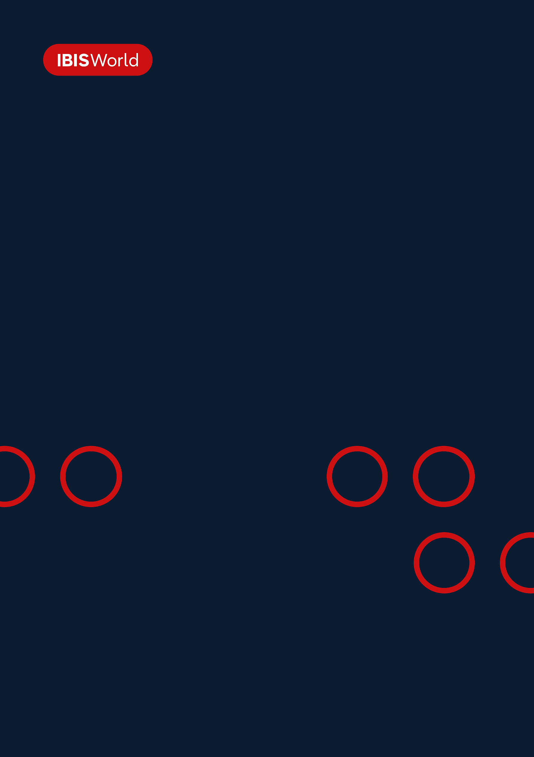
INDUSTRY REPORT
Ocean & Coastal Transportation in the US
Jun 2026

About

IBISWorld
IBISWorld specializes in industry research with coverage on thousands of global industries. Our comprehensive data and in-depth analysis help businesses of all types gain quick and actionable insights on industries around the world. Busy professionals can spend less time researching and preparing for meetings, and more time focused on making strategic business decisions.

Table Of Contents | Standard

1. About 4
Codes 4
Definition 4
Related Terms 4
What's Included 5
Companies 5
Related Industries 5
Additional Resources 6
2. At a Glance 7
Key Takeaways 7
Products and Services 8
Major Players 9
Key External Drivers 10
Industry Structure 10
SWOT 11
Executive Summary 11
3. Performance 13
Highlights 13
Key Takeaways 13
Performance Snapshot 14
Outlook 23
Life Cycle 26
4. Products and Markets 27
Key Takeaways 27
Products and Services 27
Major Markets 32
International Trade 34
5. Geographic Breakdown 35
Key Takeaways 35
Business Locations 36
6. Competitive Forces 45
Key Takeaways 45
Concentration 45
Barriers to Entry 47
Substitutes 48
Buyer & Supplier Power 51
7. Companies 53
Key Takeaways 53
Market Share 54
Companies 55
8. External Environment 67
Key Takeaways 67
External Drivers 67
Regulation & Policy 70
Assistance 71
9. Financial Benchmarks 72
Key Takeaways 72
Cost Structure 72
Financial Ratios 76
Valuation Multiples 82
Key Ratios 83
10. Key Statistics 84
Industry Data 84

1. About
https://my.ibisworld.com/us/en/industry/48311/about

Codes
NAICS 2017 - USA | 48311
NAICS 2017 - USA | 483111
NAICS 2017 - USA | 483112
NAICS 2017 - USA | 483113
NAICS 2017 - USA | 483114
NAICS 2022 - USA | 48311
NAICS 2022 - USA | 483111
NAICS 2022 - USA | 483112
NAICS 2022 - USA | 483113
NAICS 2022 - USA | 483114

Definition
This industry provides deep-sea, coastal and Great Lakes water transportation, including using the St. Lawrence Seaway. It encompasses both US-flagged and non-US-flagged vessels. Marine transportation services active on the St. Lawrence River are part of the Great Lakes Water Transportation System and, therefore, are included in this report. The industry also provides deep-sea passenger services, such as cruise ships.

Related Terms

CONTAINERIZED
Cargo that has been readied for transportation in containers.

ST. LAWRENCE SEAWAY
A network of canals and locks allows ocean-going ships to navigate from the Atlantic Ocean to the Great Lakes.

DEADWEIGHT TONNAGE
An assessment of the weight a ship currently or can securely bear regarding cargo.

CONFERENCE
A route-specific agreement between carriers to charge common freight-rates; pool revenue, costs and profit; and engage in capacity management.

FLAG OF CONVENIENCE
The practice of a national owner registering one or more vessels in another nation to avoid higher regulatory and manning costs.

TEU
Twenty-foot equivalent unit, the standard size of a shipping container; commonly used as a unit of measurement for ship capacity.

What's Included
- Deep-sea water transportation
- Coastal water transportation
- Great Lakes water transportation
- St. Lawrence Seaway water transportation

Companies
- Carnival Corporation
- Royal Caribbean Cruises Ltd
- AP Moller - Maersk Group
- Norwegian Cruise Line Holdings ltd.
- Kirby Corporation
- Hapag-Lloyd AG
- CMA CGM Group
- MSC Mediterranean Shipping Company S.A.
- Nippon Yusen Kabushiki Kaisha

Related Industries

Industries in the Same Sector
- Competitors:
  - No data available
- Complementors:
  - Inland Water Transportation in the US
  - Travel Agencies in the US
  - Non-Hotel Casinos in the US
  - Sightseeing Transportation in the US

International Industries
- Global Deep-Sea, Coastal & Inland Water Transportation
- Ocean & Coastal Transportation in Canada
- Water Freight Transport in Australia
- Water Freight Transport in New Zealand
- Sea & Coastal Freight Water Transport in the UK
- Sea & Coastal Freight Water Transport in Ireland
- Freight Transport by Sea in China

Additional Resources
- US Bureau of Transportation Statistics
- TravelDailyNews International
- US Maritime Administration
- US Census Bureau
- Cruise Lines International Association

2. At a Glance
https://my.ibisworld.com/us/en/industry/48311/at-a-glance
Revenue  $61.1bn  ’21-’26 ↑ 19.7 %  ’26-’31 ↑ 3.2 % | Employees  45,094  ’21-’26 ↑ 3.7 %  ’26-’31 ↑ 2.8 % | Businesses  878  ’21-’26 ↑ 1.7 %  ’26-’31 ↑ 2.2 %
Profit  $7.8bn  ’21-’26 ↑ 18.8 % | Profit Margin  12.7%  ’21-’26 ↓ 0.5 pp | Wages  $5.6bn  ’21-’26 ↑ 4.8 %  ’26-’31 ↑ 2.9 %

Key Takeaways

Performance
- The industry narrowed its pricing disadvantage with land-based vacations by shifting toward luxury offerings. Premium positioning and high-end amenities attracted affluent travelers, driving double-digit growth in the luxury segments.
- Rising US LNG exports are boosting long-term energy shipping demand but new US-flag rules complicate the response. Export capacity is set to climb sharply, yet tighter requirements for US-flag and US-built LNG carriers raise costs and could delay fleet expansion.

Products and Markets
- Higher-income travelers are driving cruise demand through increased vacation spending. Affluent consumers' growing preference for premium cruise experiences is translating into strong booking growth for luxury brands.
- Declining commodity shipments are weighing on Great Lakes freight revenue. Weakening iron ore and coal demand reflects broader challenges in domestic production and shifts in the energy market.

Products and Services
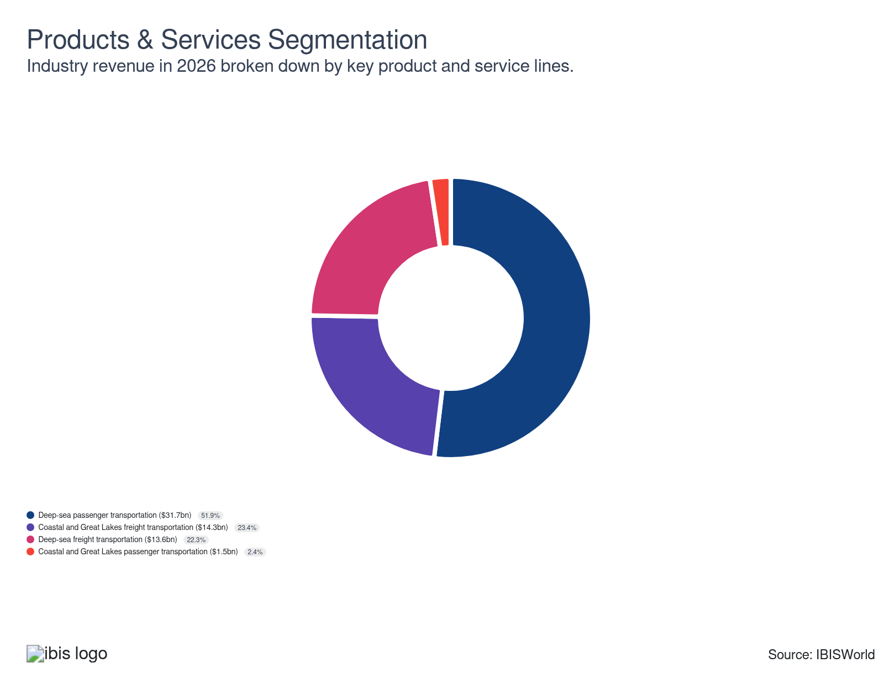

Major Players
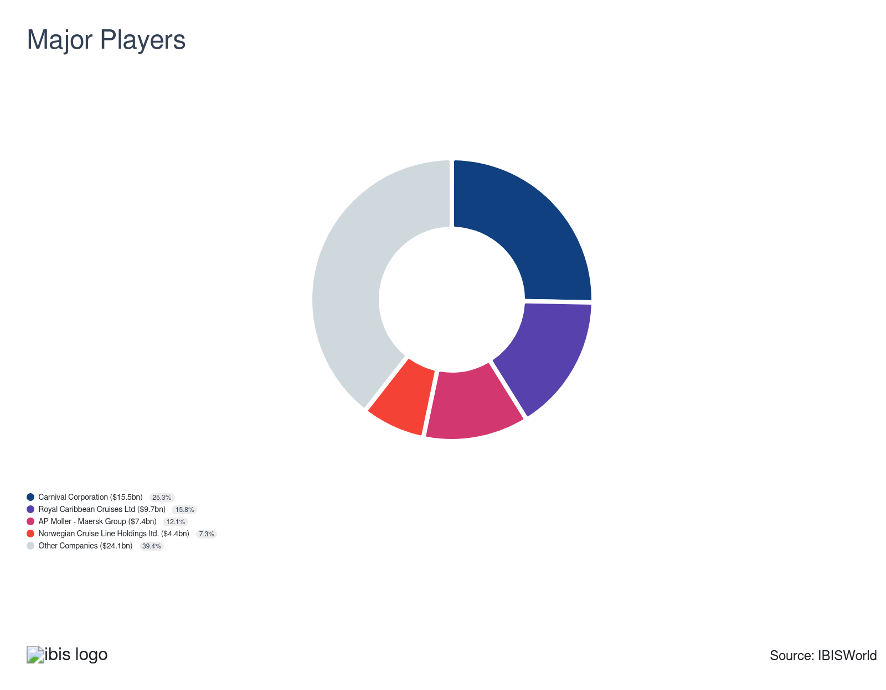

Key External Drivers
Key External Drivers | Impact
International trips by US residents | Positive
Inbound trips by non-US residents | Positive
Domestic trips by US residents | Positive
Investor uncertainty | Negative

Industry Structure
Characteristic | Level | Trend
Concentration | Moderate
Barriers To Entry | Moderate | Steady
Regulation and Policy | Moderate | Increasing
Life Cycle | Growth
Revenue Volatility | Very High
Assistance | Moderate | Steady
Competition | Moderate | Increasing
Innovation | Moderate

SWOT
Strengths  Growth Life Cycle Stage  Low Imports  High Profit vs. Sector Average  High Revenue per Employee | Weaknesses  Very High Volatility  High Customer Class Concentration  High Product/Service Concentration  High Capital Requirements | Opportunities  High Revenue Growth (2021-2026)  High Revenue Growth (2026-2031)  High Performance Drivers | Threats  Low Revenue Growth (2005-2026)  Low Outlier Growth

Executive Summary

Head above water: The cruise segment drove industry revenue growth through premium pricing, while maritime shipping faced margin pressure from excess capacity and declining freight rates, forcing operational cost reductions.
The container shipping industry faces mounting pressure from overcapacity, highlighting the sector’s current struggles and raising concerns about market stability. Vessel additions that were intended to ease past supply shortages have instead flooded the market, driving down freight rates and squeezing operator profit. Although increased chartering initially helped meet strong demand, the resulting capacity surplus has ultimately eroded profitability across the sector. In response, operators are focusing on cost-reduction measures and investing in more sophisticated freight and capacity forecasting tools to stabilize their operations. At the same time, higher energy costs linked to tensions with Iran are pushing up bunker fuel costs, prompting carriers to introduce surcharges to provide some margin relief, even as persistent capacity growth keeps rates under pressure. A potential ceasefire could ease fuel costs but might also allow freight rates to fall back toward more typical market levels, creating uncertainty for revenue growth and leaving the overall impact on the industry difficult to predict.
The cruise industry demonstrates markedly different momentum, offering a sense of optimism for stakeholders. Pandemic pricing pressure initially compressed profit as cruise fares fell relative to land-based alternatives, despite offering substantial value. As travel demand recovered, cruise operators raised fares—supported by strengthened consumer demand and normalized market conditions. This pricing strategy repositioned cruising as a premium segment, with fares rising to levels above those of competing vacation options. Revenue grew at a CAGR of 19.7% over five years to reach $61.1 billion in 2026, up 1.5% in 2026 alone. The divergence between cruise and container shipping reflects distinct market dynamics within the maritime sector, with cruise operators benefiting from pricing power. In contrast, container shipping navigates structural capacity challenges and margin compression.
The industry will continue to evolve as operators balance new regulations with growth ambitions. Rising US LNG exports create room to expand energy shipping, but 2025 rules that gradually require US-built, US-flag vessels from 2028 will increase costs and make careful fleet planning essential. On the passenger side, cruise lines are adding megaships to capture strong demand. Yet, capacity constraints at traditional homeports are forcing them to redeploy vessels from alternative states that can handle larger ships. At the same time, the push for cleaner energy and stricter emissions rules is encouraging companies to invest in lower-emission technologies. These greenhouse-friendly technologies will spread through the fleet over the long term. Efforts to replace paper documentation with interoperable electronic systems also remain underway and, once fully adopted, are expected to generate significant cost savings and efficiency gains, supporting projected revenue growth at a 3.2% CAGR to $71.4 billion by 2031.

3. Performance
https://my.ibisworld.com/us/en/industry/48311/performance

Highlights
Revenue  $61.1bn  2021-26 CAGR ↑ 19.7 %  2026-31 CAGR ↑ 3.2 % | Employees  45,094  2021-26 CAGR ↑ 3.7 %  2026-31 CAGR ↑ 2.8 % | Businesses  878  2021-26 CAGR ↑ 1.7 %  2026-31 CAGR ↑ 2.2 %
Profit  $7.8bn  2021-26 CAGR ↑ 18.8 % | Profit Margin  12.7%  2021-26 CAGR ↓ 0.5 pp

Key Takeaways
- The industry narrowed its pricing disadvantage with land-based vacations by shifting toward luxury offerings. Premium positioning and high-end amenities attracted affluent travelers, driving double-digit growth in the luxury segments.
- Rising US LNG exports are boosting long-term energy shipping demand but new US-flag rules complicate the response. Export capacity is set to climb sharply, yet tighter requirements for US-flag and US-built LNG carriers raise costs and could delay fleet expansion.

Performance Snapshot
Revenue: | ↑ 2021-26 Revenue CAGR +19.7%
Revenue  $61.1bn  ’21-’26 ↑ 19.7 %  ’26-’31 ↑ 3.2 % | 2026 Revenue Growth  ↑ 1.6 % | Revenue Volatility  Very High
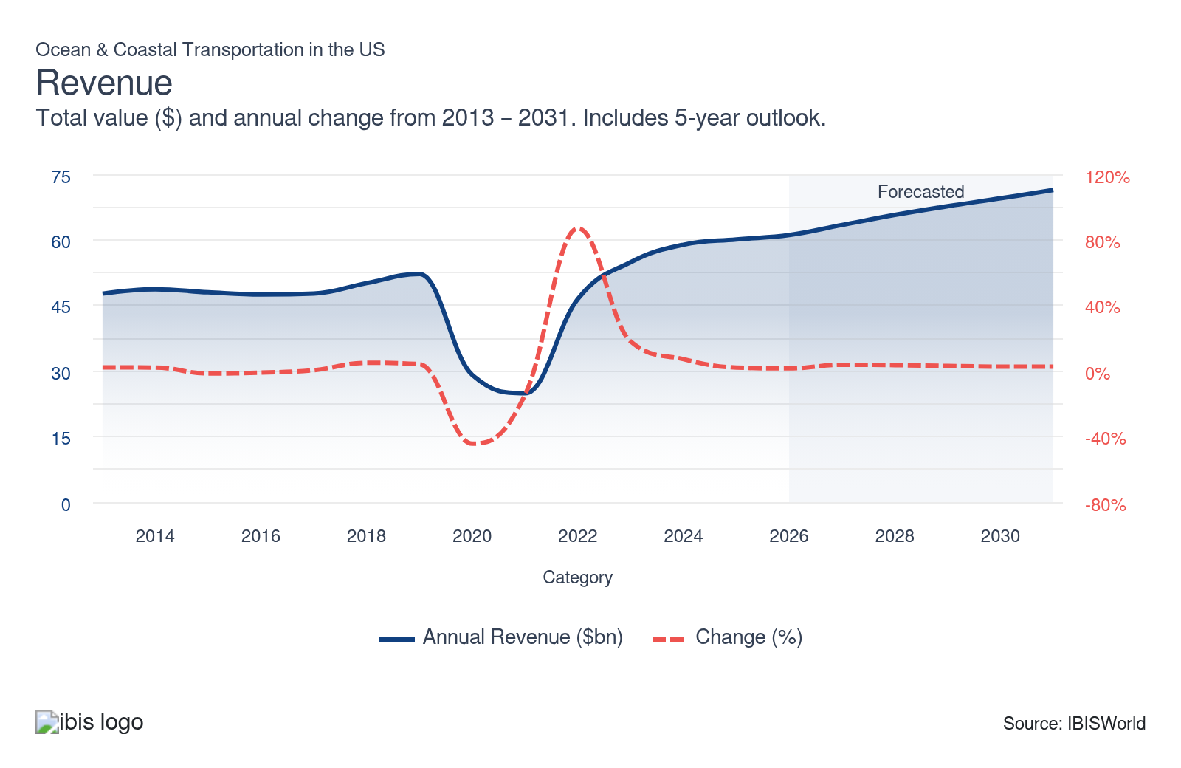
Employees: | ↑ 2021-26 Employees CAGR +3.7%
Employees  45,094  ’21-’26 ↑ 3.7 %  ’26-’31 ↑ 2.8 % | Employees per Business  51  ’21-’26 ↑ 1.9 %  ’26-’31 ↑ 0.6 % | Revenue per Employee  $1m  ’21-’26 ↑ 15.5 %  ’26-’31 ↑ 0.4 %
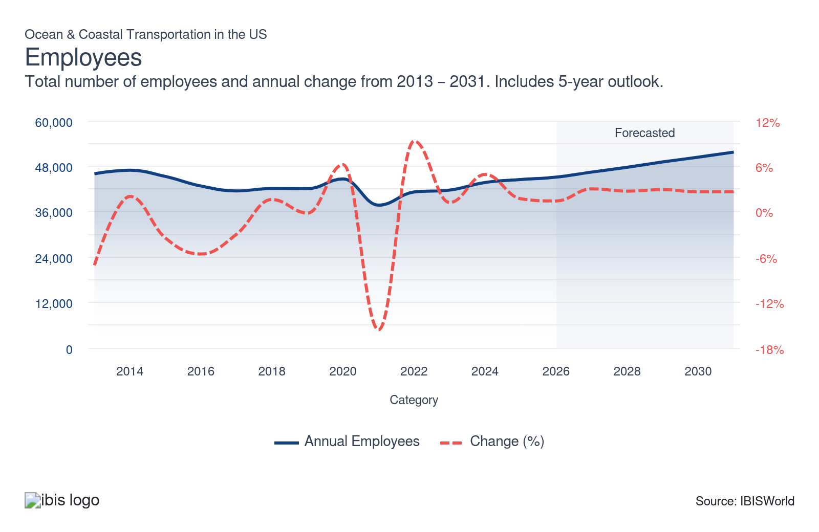
Businesses: | ↑ 2021-26 Business CAGR +1.7%
Businesses  878  ’21-’26 ↑ 1.7 %  ’26-’31 ↑ 2.2 % | Employees per Business  51  ’21-’26 ↑ 1.9 %  ’26-’31 ↑ 0.6 % | Revenue per Business  $69.6m  ’21-’26 ↑ 17.7 %  ’26-’31 ↑ 1.0 %
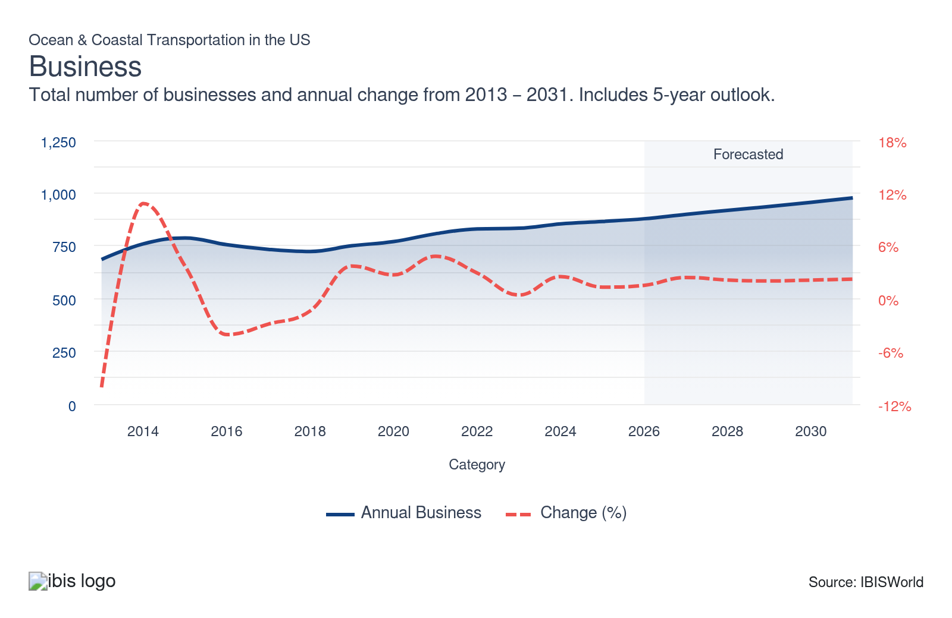
Profit: | ↑ 2021-26 Profit CAGR +18.8%
Total Profit  $7.8bn  ’21-’26 ↑ 18.8 % | Profit Margin  12.7%  ’21-’26 ↓ 0.5 pp | Profit per Business  $8.8m
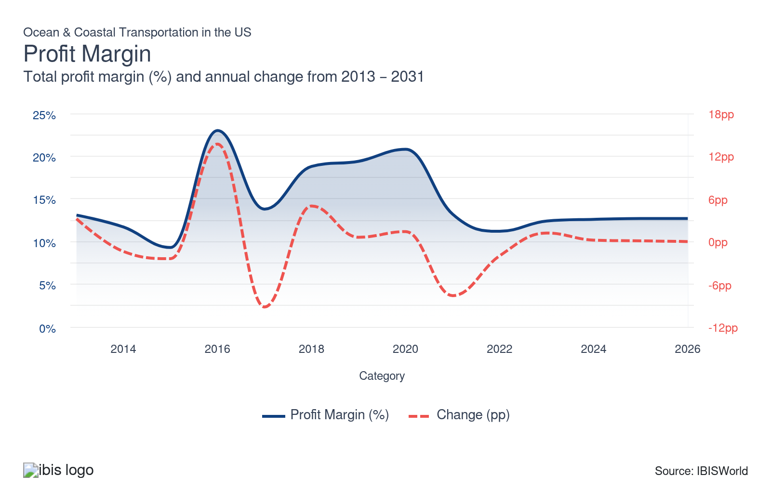
Current Performance
Current Performance

What's driving current industry performance?

Cruise industry closes pricing gap with land-based vacations through luxury repositioning
- The cruise industry faced a significant competitive disadvantage during the pandemic recovery. Historically 20.0% cheaper than land-based vacations, the pricing gap widened to 40.0–45.0% by 2023 as land travel rebounded faster than cruise capacity came online, according to Royal Caribbean CEO Jason Liberty. The industry offered discounted fares to encourage travelers to return after pandemic-related travel restrictions and negative profitability. However, as travel demand normalized, operators shifted strategy from volume-based discounting to premium pricing and product differentiation to close the competitive gap and rebuild profit.
- Cruise operators raised fares and eliminated affordable options as passenger volumes recovered to pre-pandemic levels by 2023, according to the Cruise Lines International Association (CLIA). Tynan Smith, founder of Cruise Sheet, documented this shift: cruises priced under $50 per day dropped from 45 offerings in July–December 2022 to 11 by 2024. Royal Caribbean narrowed its pricing disadvantage to 30.0% by 2023 through strategic price increases. This repositioning reduced affordability but improved per-passenger revenue and profitability by targeting higher-income travelers willing to pay premium prices.
- Cruise lines deployed luxury vessels and amenities to capture affluent market segments. Royal Caribbean launched Icon of the Seas, featuring dining outlets, shopping and neighborhood hubs designed for large-group travelers. According to CLIA's 2025 travel agent survey, luxury and premium cruise markets reported double-digit growth, validating the industry's premium positioning strategy. This shift toward high-yield, luxury-focused operations strengthened deep-sea cruise segments as the industry's most significant revenue driver, demonstrating that premium market capture generates superior returns compared to price-competitive strategies.

Vessel expansion and falling rates weaken freight margins
- Ocean carriers responded to severe capacity shortages during the pandemic recovery by aggressively ordering ships and chartering additional vessels. Averitt reported in 2021 that 37.0% of shippers experienced capacity issues, a 12.0% increase from 2020, as port congestion and strong consumer spending strained available slot availability. Tight capacity drove the Shanghai Containerized Freight Index (SCFI) to $5,000 per TEU by late 2021, creating powerful financial incentives for carriers to expand fleets and capture elevated spot rates.
- Major carriers significantly scaled capacity through ownership and chartering. Hapag-Lloyd owned 131 vessels and chartered 168 by 2024, compared to 113 owned and roughly 140 chartered in 2021, increasing aggregate container capacity to 3,654 TTEU. This capacity expansion was designed to address demand surges and prevent competitors from capturing market share during the high-rate environment.
- Capacity additions outpaced demand recovery, reversing the market dynamic. By 2022, the share of shippers reporting capacity challenges declined to 22.0%, according to Averitt. The SCFI fell to $2,460 per TEU by December 2024, a 50.0% drop from the 2021 peaks. Excess supply over demand compressed freight rates and revenue per container, eliminating the pricing power carriers had enjoyed in the past, leading to the producer price index for seaport sea freight falling 0.8% and 2.0% YOY in 2023 and 2024, respectively.
- Weaker freight rates are now forcing carriers to adapt business models and cost structures. Maersk implemented workforce reductions in 2023 to trim operating expenses and Hapag-Lloyd developed more granular forecasting tools to reduce empty sailings and improve utilization, aiming to stay competitive in a lower-rate environment even if this means accepting structurally thinner profit in the near term.

Iran-related fuel shocks and rate actions drive 2026 earnings
- The Iran conflict is driving bunker costs sharply higher and increasing operating pressure for ocean and coastal carriers. Very low sulfur fuel oil VLSFO briefly reached about 1,068 dollars per metric ton in March 2026, compared with typical 2023–2025 levels below 800 dollars, and stayed above 800 dollars per metric ton by June 2026, leaving fuel costs markedly higher year over year.
- Fuel’s large share of operating expenses is turning rising energy into significant earnings pressure, with Hapag-Lloyd CEO Rolf Habben Jansen estimating in March 2026 that the conflict was adding roughly 40.0 to 50.0 million dollars per week to company costs and Maersk CEO Vincent Clerc stating in May 2026 that monthly fuel expenses were running about 500.0 million dollars above expected levels after rising by nearly two-thirds.
- Carriers are responding with fuel surcharges and contract resets to recover more of these higher costs and support near-term profitability. Maersk, Hapag-Lloyd and other lines introduced temporary fuel surcharges on spot shipments early in the conflict and are now rolling them into contract cargo, with Hapag-Lloyd set to apply a revised Marine Fuel Recovery mechanism to all shipments from July 2026, replacing earlier environmental fuel surcharges. Many annual contracts are scheduled to reset on July 1, locking in higher bunker-linked charges and embedding elevated fuel costs into longer-term pricing.
- Anticipation of these higher rates is pulling some demand forward into the first half of the year, temporarily supporting volumes. Collin Shaw, president of the MEMA vehicle supplier association, told Reuters in June 2026 that vehicle suppliers are front-loading shipments to secure essential components before July surcharges take effect, boosting container volumes ahead of peak pricing and giving carriers additional revenue to offset higher fuel bills.
- Industry sources expect earnings to improve in the near term but highlight growing risks later in 2026. Seko Logistics vice president of global ocean product Clint Dvorak told Sourcing Journal in May 2026 that he expects stronger demand and higher rates to lift carrier earnings in the second quarter after a weaker first quarter. Still, he also warned that structural capacity growth is likely to outpace demand by year-end, limiting sustained rate gains even if the conflict persists.
- Geopolitics add another layer of uncertainty to freight-side performance through the rest of the year. Carriers such as Maersk have flagged slow steaming, in which ships operate at lower speeds to conserve fuel, as a potential response if bunker prices remain elevated. Separately, Ian Lewis noted on TradeWinds’ Wavelength podcast in June 2026 that a ceasefire and renewed transit through the Strait of Hormuz could quickly lower fuel and congestion costs and risk a correction in ocean freight rates, underscoring how sensitive current performance is to the conflict’s direction.

Cybersecurity threats are pushing carriers to boost digital defenses
- According to Marlink, the number of cybersecurity threats targeting the industry has increased significantly. Medium—and low-risk alerts rose from an average of nearly 75,000 per month in 2023 to 100,000 in January 2024, reaching as high as 270,000 in April. This sharp rise highlights escalating digital vulnerabilities that could disrupt the industry's business operations and data security.
- Maritime cybersecurity incidents can severely disrupt operations, temporarily shutting down shipboard systems and putting navigation at risk. Those risks range from theft of confidential financial data, which could facilitate impersonation, scams, or fraud, to potential tampering with navigation technologies, making ships vulnerable to collision or route manipulation if hackers breach systems.
- The reputational risk follows closely behind operational hazards, as successful attacks make companies appear unreliable and unsafe, potentially driving clients to alternative providers. The pressure to protect financial information and proprietary navigational systems has resulted in heightened investment: according to DNV Cyber, almost 60.0% of maritime professionals say their companies increased spending on operational technology cybersecurity in 2024 compared to the previous year.
- While these investments help limit exposure to cyberattacks and promote more stable operations, they also carry drawbacks, including higher short-term operating costs. Carriers must deploy specialized IT and cybersecurity professionals, increasing their wage expenses. Although these investments are crucial for long-term resilience and customer trust, they may weigh on profit soon as carriers adjust to the new security landscape.

What influences industry volatility?

Trade policy shocks and capacity swings drive ocean freight volatility
- Liner operators face uneven revenue when spot container freight rates swing rapidly, since short-term contracts and ad hoc bookings tie a portion of earnings to volatile indices such as the Shanghai Containerized Freight Index SCFI. Hapag-Lloyd reported that the SCFI fluctuated through the first half of 2025, with rates stabilizing in the first quarter before rebounding by May as shippers front-loaded volumes in response to announced import tariffs, temporarily lifting revenue.
- By the third quarter of 2025, Hapag-Lloyd’s revenue declined 5.0% annually as front-loading eased, added capacity was absorbed and freight rates normalized, offsetting earlier gains. These dynamics highlight how trade policy shocks, capacity additions and demand timing distort earnings in an industry where structural fleet growth is already outpacing underlying consumer demand.

Fuel cost volatility amplifies revenue instability across both segments simultaneously
- At 42.7% of revenue, Other Costs, the category capturing fuel, port charges and vessel operating expenses, is the industry's largest cost line and sits 15.7 percentage points above the broader transportation sector average. This unusually large cost exposure means bunker price swings transmit directly and at scale into operating profit, making fuel the dominant source of within-cycle volatility after demand shocks have settled.
- As a result of the Iran war, elevated crude prices reached multi-year highs by mid-March 2026. Carnival Corporation absorbed a roughly $500 million incremental fuel headwind for full-year 2026, per Carnival Corporation (2026), forcing a guidance reduction from $2.48 to $2.21 in Adjusted EPS. On the freight side, Hapag-Lloyd's unit costs rose to approximately $1,420/TEU, above its average freight rate of $1,330/TEU, with bunker cost increases identified as a key driver, per Hapag-Lloyd (2026). A single geopolitical event thereby compressed margins in both cruise and freight simultaneously, demonstrating why volatility remains elevated regardless of demand conditions.
- Given fuel's outsized weight in the cost base, operators have pursued partial hedging to limit exposure rather than absorb it entirely. Royal Caribbean Group (2026) reported 59% of FY2026 fuel hedged at approximately $475/metric ton, while container carriers, including Maersk and Hapag-Lloyd, imposed Emergency Bunker Surcharges across affected trade lanes to recover a portion of the cost increase from shippers.

How do successful businesses overcome volatility?
Incorporate long-term sales contracts
Cruise operators using booking programs with large non-refundable deposits and coastal barge carriers renewing multi-year term contracts reduce revenue exposure to spot market fluctuations and short-term demand shocks.
Leverage the company's financial position
Operators with strong liquidity, such as carriers, can absorb cost shocks without distress asset sales or capacity cuts that would amplify revenue volatility during downturns. Financial strength converts liquidity from a buffer into a competitive stabilizer.
Outlook | ↑ 2026-31 Revenue CAGR +3.2%

What's driving the industry outlook?

Larger cruise ships and port limits reshape future deployment
- The cruise orderbook is tilting toward larger vessels, which will change fleet composition and deployment decisions over the outlook period. Cruise Lines International Association CLIA data indicate that ships with at least 3,000 lower berths account for 28.3% of the fleet in 2026, up from 24.6% in 2021 and the association projects this share to reach 31.8% by 2037, reflecting operators’ preference for higher-capacity ships that can support more onboard revenue.
- Industry feedback points to strong commercial performance from recent megaships, such as Royal Caribbean’s Icon of the Seas, which has encouraged additional large-ship orders for delivery around 2030. RacQuelle Major-Holland, owner of Major Adventures Travel Agency, told USA Today in 2026 that these vessels attract travelers by offering “floating city” experiences and expanded amenities, helping cruise lines command higher yields.
- Port infrastructure constraints are emerging as a key risk to this large-ship strategy, especially in Florida, the traditional hub for Caribbean cruising. Port Canaveral CEO Captain John Murray stated in 2024 that major South Florida ports, including Miami and Port Everglades, are effectively full for additional large-ship berths and that Port Canaveral is starting to turn away new business because of space limitations, raising concerns about where future megaships will homeport.
- Cruise lines are responding by shifting deployment toward alternative Gulf Coast ports that can accommodate new tonnage and tap regional demand. Royal Caribbean plans to deploy Icon of the Seas from Galveston, Texas, starting in August 2027, while Carnival intends to base its megaship, Carnival Tropicale, there from 2028, signaling a gradual rebalancing of homeports away from congested Florida terminals toward emerging hubs that offer more room for growth.

US LNG export growth and ship rules reshape energy transportation strategies
- Rising US liquefied natural gas LNG export capacity underpins long-term demand for ocean and coastal transportation, particularly in energy shipping. The US Energy Information Administration EIA reported in 2025 that North America’s LNG export capacity could roughly double by 2029, supported by pipeline expansions and new Gulf Coast export terminals and forecasts that the United States could account for about one-third of global LNG supply by the late 2020s, up from 24.0% in 2024, as buyers in Europe and elsewhere pivot away from Russian gas.
- Anticipation of this growth is already shaping fleet and asset decisions. Overseas Shipholding Group announced in December 2023 that it would invest in life-extension upgrades on four Jones Act-compliant tankers serving Alaska, signaling an early move to capture expected increases in US crude and LNG-related traffic.
- However, policy changes are creating both opportunity and risk for LNG shipping operators. In early 2025, the USTR directed that from April 2028, at least 1.0% of US LNG exports must move on US-flagged ships, with a further requirement that 1.0% sail on US-built ships one year later and phased annual increases thereafter, effectively tying future growth to vessels that meet Jones Act-style ownership, flagging and construction criteria.
- Industry groups warn that these rules could constrain capacity and raise costs if ship supply doesn’t keep pace. The American Petroleum Institute argued in April 2025 that the US fleet of LNG-capable, US-built vessels is too small to meet the mandate, while LNG Industry reported that Hanwha Ocean’s July 2025 order for an LNG carrier at Hanwha Philly Shipyard is the first US-ordered LNG ship since the late 1970s, illustrating how slowly new compliant capacity is emerging.
- Operators and policymakers are exploring ways to soften the transition, which will shape the medium-term outlook. BIMCO notes that foreign-built LNG carriers could be reflagged to the United States if owned by US entities and enrolled in programs such as the Maritime Security Program and that rules in the USTR order include grace periods for companies that order US-built vessels within an approximate three-year window. However, higher build costs and longer lead times still threaten to compress profit and delay some projects.

Digital documentation and eBL adoption drive investment strategies
- Documentation bottlenecks continue to weigh on ocean and coastal transportation, as a 2024 ODEX survey found that 50.0% of logistics respondents cited delays, errors and difficulty accessing original documents as leading operational pain points. OECD research in 2025 similarly highlighted the sector’s heavy reliance on paper-based trade documentation, which prolongs processing times and increases the risk of errors and lost paperwork across global supply chains.
- These frictions are pushing carriers and logistics chains toward electronic bills of lading eBLs, which McKinsey estimates could save about 6.5 billion dollars in annual documentation costs by reducing printing, handling and storage requirements and enabling faster, digital title transfers. FIT Alliance survey data from 2024 indicates that carriers are early adopters, with roughly 74.0% reporting some use of eBLs and nine DCSA member lines, including MSC, Maersk and Hapag-Lloyd, committing to convert 100.0% of bills of lading to electronic format by 2030.
- Industry-wide adoption remains uneven, with just 12.8% of the broader logistics sector using eBLs, reflecting partner readiness and interoperability challenges across siloed platforms that currently limit end-to-end digital workflows. FIT Alliance reports that 58.0% of carriers still operate hybrid paper–eBL processes. At the same time, Singapore’s Infocomm Media Development Authority notes that most eBL providers don’t yet offer seamless connections to rival platforms, forcing many trades to rely on manual or semi-digital workarounds.
- Recent initiatives aim to address these constraints, as illustrated by CMA CGM’s 2025 memorandum of understanding with eTEU and CargoX to trial interoperable blockchain-based eBL solutions that can work across platforms. If these efforts scale, rising interoperability and partner readiness should accelerate eBL adoption, enabling carriers and shippers to fully capture cost savings, reduce documentation-related delays and support a more efficient digital trade environment over the outlook period.

Tightened emission regulations and rising costs shape the outlook for ocean and coastal transport
- Stricter global emissions standards set by the International Maritime Organization are pressuring large ocean carriers operating to invest in greener technologies and environmentally safer fuels, such as green methanol and LNG. Starting in 2027, larger vessels will face enforcement of an 8.0% reduction in greenhouse gas intensity by 2030, with financial penalties for non-compliance potentially threatening profitability.
- Major shipping companies must proactively sign long-term agreements with alternative fuel suppliers to ensure sufficient access to bio-methanol and similar low-emission fuels. For example, Maersk’s deal with LONGi Green Energy Technology is set to cover more than half of its dual-fuel methanol requirements by 2027, accelerating industry adoption of engines that can operate on both traditional oil and greener alternatives.
- These regulatory and technological shifts require substantial capital investment in new vessels and retrofitting existing fleets, driving operating costs. Additional supplier agreements also mean higher upfront expenditure, making cost management a central concern for carriers. While these changes help carriers avoid heavy fines, they also narrow profit, making the economics of deep-sea freight increasingly complex during the transition period.
- The resulting cost increase and regulatory hurdles will temper growth in the deep-sea freight transportation segment and discourage new entrants, as the business case for operating and maintaining compliant vessels becomes less compelling. Likewise, passenger transport via cruises could weaken interest if regulatory burdens and related costs remain high, reinforcing a broader industry slowdown through the latter part of the decade.
Life Cycle | Growth

Why is the industry growing?

Contribution to GDP
The industry's contribution to GDP has grown during the period as cruise demand expanded. Strong leisure travel spending supports employment across hospitality, logistics and port operations. Cruise lines function as a significant economic driver, generating direct revenue and supporting downstream economic activity through consumer spending and job creation.

Market Saturation
The industry has a higher market saturation because of complex entry barriers, such as brand recognition. This maturity level makes it harder for new competitors to enter and disrupt the industry.

Innovation
The industry has accelerated innovation to enhance consumer experience and operational efficiency. Cruise operators have introduced advanced booking systems, wristband technology for onboard tracking and virtual reality systems to differentiate offerings and improve guest engagement. These innovations reflect industry efforts to strengthen competitive positioning and justify premium pricing in an increasingly competitive leisure travel market.

Consolidation
The industry has experienced consolidation as barriers to entry have increased. Established carrier alliances and the scale of major cruise operators create significant competitive advantages. Larger cruise lines benefit from brand recognition, customer loyalty and operational efficiency, positioning them to capture market share more effectively than smaller competitors or new entrants.

Technology & Systems
Automation in ocean and coastal transportation is on the horizon. The development of fully autonomous container ships like Yara International's Yara Birkeland could significantly reduce wage costs, transforming operational dynamics in the sector.

4. Products and Markets
https://my.ibisworld.com/us/en/industry/48311/products-and-markets
Largest Market  $31.7bn  Deep-sea passenger transportation | Product Innovation  Moderate

Key Takeaways
- Higher-income travelers are driving cruise demand through increased vacation spending. Affluent consumers' growing preference for premium cruise experiences is translating into strong booking growth for luxury brands.
- Declining commodity shipments are weighing on Great Lakes freight revenue. Weakening iron ore and coal demand reflects broader challenges in domestic production and shifts in the energy market.

Products and Services
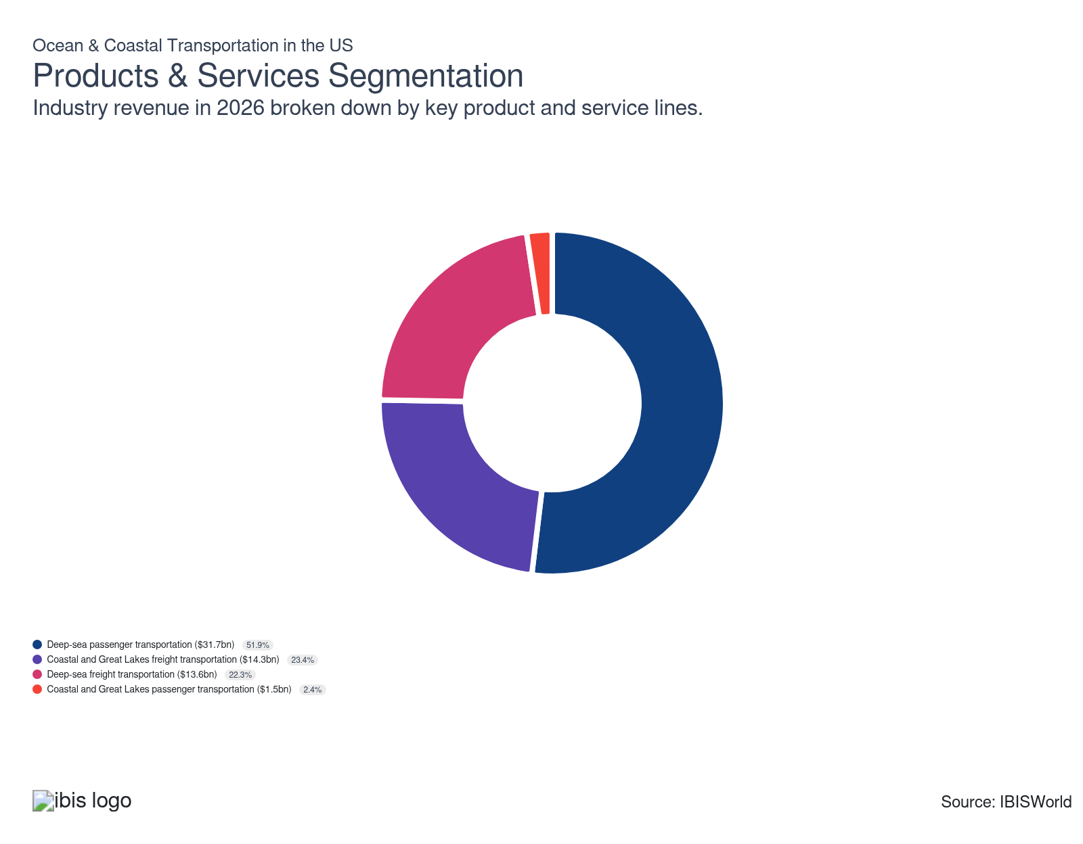

How are the industry’s products and services performing?

Deep sea passenger cruises gain from strong demand for Alaska and exotic destinations
- Deep-sea passenger services are multi-day ocean voyages on large cruise ships that transport travelers between ports while bundling transportation with lodging, food, entertainment and excursions on routes such as the Caribbean, Mediterranean, Alaska and transatlantic crossings. This product holds the largest share of industry revenue because it operates high-occupancy vessels on repeatable itineraries, captures upfront ticket payments and substantial onboard spending and benefits from strong brand loyalty and bookings that reduce revenue volatility compared to freight rates tied to trade cycles.
- Demand for deep-sea cruises rebounded as travelers increasingly sought culturally and naturally exotic destinations. Alaska experienced robust growth, driven by interest in cruisetours to destinations such as Denali National Park. According to Carnival Corp's CEO, Alaskan voyages grew substantially in 2024, bolstered by ongoing demand for itineraries that reach remote natural attractions, strengthening this segment's performance.

Great Lakes freight declines as iron ore and coal shipments weaken
- Great Lakes freight services move bulk and break-bulk cargoes such as iron ore, grain, coal, aggregates and steel through the Great Lakes–St. The St. Lawrence Seaway serves as the inland heavy-industry arm of ocean and coastal transportation, connecting Midwest production hubs to global export routes. This traffic generates the third-largest revenue footprint in the maritime system because it reliably serves steel mills, power plants and grain terminals at a low cost per ton, providing steady freight revenue even when containers or cruise ships experience volatility.
- Great Lakes freight contracted because of declining commodity shipments. Iron ore shipments fell 8.0% in 2025 from the five-year average (2020–2025), according to the Lake Carriers Association, reflecting weak domestic production and manufacturing output. Coal shipments also declined, with the St. Lawrence Seaway Management Corporation reporting a 6.3% year-over-year drop in cargo tonnes in 2024 as coal phases out of energy markets. These commodity declines reduce shipping demand and revenue opportunities in the region.

Deep-sea freight faces margin pressure from oversupply and declining tariff-driven trade
- Deep-sea freight services transport containerized goods and break-bulk cargo across intercontinental routes (Asia–Europe, Asia–North America, intra-Asia), forming the backbone of global supply chains through container ships operated by major carriers. This segment holds the largest share of ocean and coastal transportation revenue because containerized trade dominates merchandise shipping and generates consistent freight revenue from global commerce flows, reliably moving consumer goods, electronics, apparel and manufactured products that drive retail and industrial activity worldwide.
- Excess shipping capacity, compressed freight rates and limited revenue growth. US tariffs imposed in 2025 initially boosted frontloaded exports and imports, but moderating trade gains in the second half of 2025 reduced carrier exposure on these routes. According to HMM, a container carrier, Shanghai Container Freight Index spot rates for North American routes fell 70.0% westbound and 63.0% eastbound year-over-year in Q3 2025, substantially lowering this segment's revenue gains and profitability.

Great Lakes passenger services decline as cruise lines shift capacity elsewhere
- Great Lakes passenger services are small-ship cruises and overnight voyages on the binational Great Lakes–St. Lawrence system, typically operating 100–400-guest vessels calling at regional ports such as Milwaukee, Cleveland, Toronto, Duluth and smaller coastal communities. This segment holds the lowest share of industry revenue because of structural constraints: a short May–October season, weather-sensitive itineraries, strict Seaway draft limits and relatively small vessels that keep total capacity and yield far below those of global ocean cruising, which is concentrated on year-round warm-water routes.
- Great Lakes passenger services contracted as cruise lines reduced regional operations in 2025. The Port of Milwaukee saw cruise ship passenger arrivals drop 18.0% year-over-year amid fewer vessel calls during the season. According to Korey Garceau, a forecast in February 2025 indicated that cruise lines took operational breaks in the region to deploy capacity elsewhere, creating uneven financial performance for regional ports dependent on seasonal cruise traffic.

What are innovations in industry products and services?

Virtual reality amenities differentiate cruise offerings and enhance passenger experience
- Cruise operators are deploying virtual reality technology to create premium onboard experiences and differentiate their products. Royal Caribbean's Navigator of the Seas features "Virtual Balconies"—cabin screens that display real-time exterior feeds, allowing interior cabin passengers to experience balcony views. Norwegian Cruise Line offers immersive VR cabins where passengers can explore historical periods and environments, providing experiential value beyond traditional cruise accommodations and appealing to tech-savvy, affluent travelers.
- VR amenities serve as value-added features that justify premium pricing and enhance customer satisfaction. These installations require significant capital investment in hardware and software infrastructure, increasing operational complexity but strengthening competitive differentiation. As cruise lines vie for luxury market share, VR experiences represent a tangible product innovation that enhances perceived value and supports the industry's shift toward high-yield, premium-focused market positioning.

Wristband technology streamlines onboard payments and passenger convenience
- Cruise operators are deploying advanced wristband technology to enhance passenger convenience and streamline onboard transactions. Royal Caribbean's updated WOW Bands, introduced in 2025, feature wearable-inspired designs and rigid construction that improve durability compared to previous flat designs. These optional devices allow guests to make purchases and access deck areas through tap technology, reducing friction in the onboard experience and creating a seamless payment ecosystem.
- Wristband innovation reflects industry efforts to improve guest satisfaction and operational efficiency. Disney Cruise Line launched DisneyBand+ in 2023, featuring extended battery life and software update connectivity that reduces maintenance complexity. These technological investments generate competitive differentiation while improving the guest experience, supporting the industry's shift toward premium positioning and higher per-passenger spending through frictionless payment systems.

Digital booking platforms streamline freight transactions and improve customer experience
- Major carriers are investing in user-friendly digital booking platforms to enhance operational efficiency and customer satisfaction. Hapag-Lloyd launched a beta booking service featuring guided workflows and dispute tracking functionality that allows customers to monitor resolution progress in real time. These tools reduce friction in the booking process and address customer pain points, strengthening carrier positioning with shippers seeking accessible, transparent solutions for managing freight transactions.
- CMA CGM enhanced its SpotOn service by adding reefer quotes, enabling instant pricing for refrigerated cargo shipments. These digital innovations reflect industry efforts to simplify booking processes and expand service accessibility. By automating quote generation and streamlining transaction workflows, carriers reduce administrative overhead while improving customer experience, supporting competitive differentiation in a freight market where operational convenience increasingly influences client retention and contract awards.

What products or services do successful businesses offer?
Produce a differentiated product
Cruise lines and coastal carriers that develop proprietary destination experiences, exclusive port infrastructure, or specialized vessel configurations generate booking premiums and pricing power that commodity route carriers cannot sustain. Private island destinations and luxury sub-brand expansion illustrate this differentiation advantage at the segment level.
Leverage product design, quality and brand strengths
Brand equity drives advance booking conversion, onboard yield, and repeat purchase rates. Carriers with established fleet quality, safety records, and loyalty programs retain pricing leverage through demand cycles, while newer or undifferentiated entrants compete primarily on spot price.

Major Markets
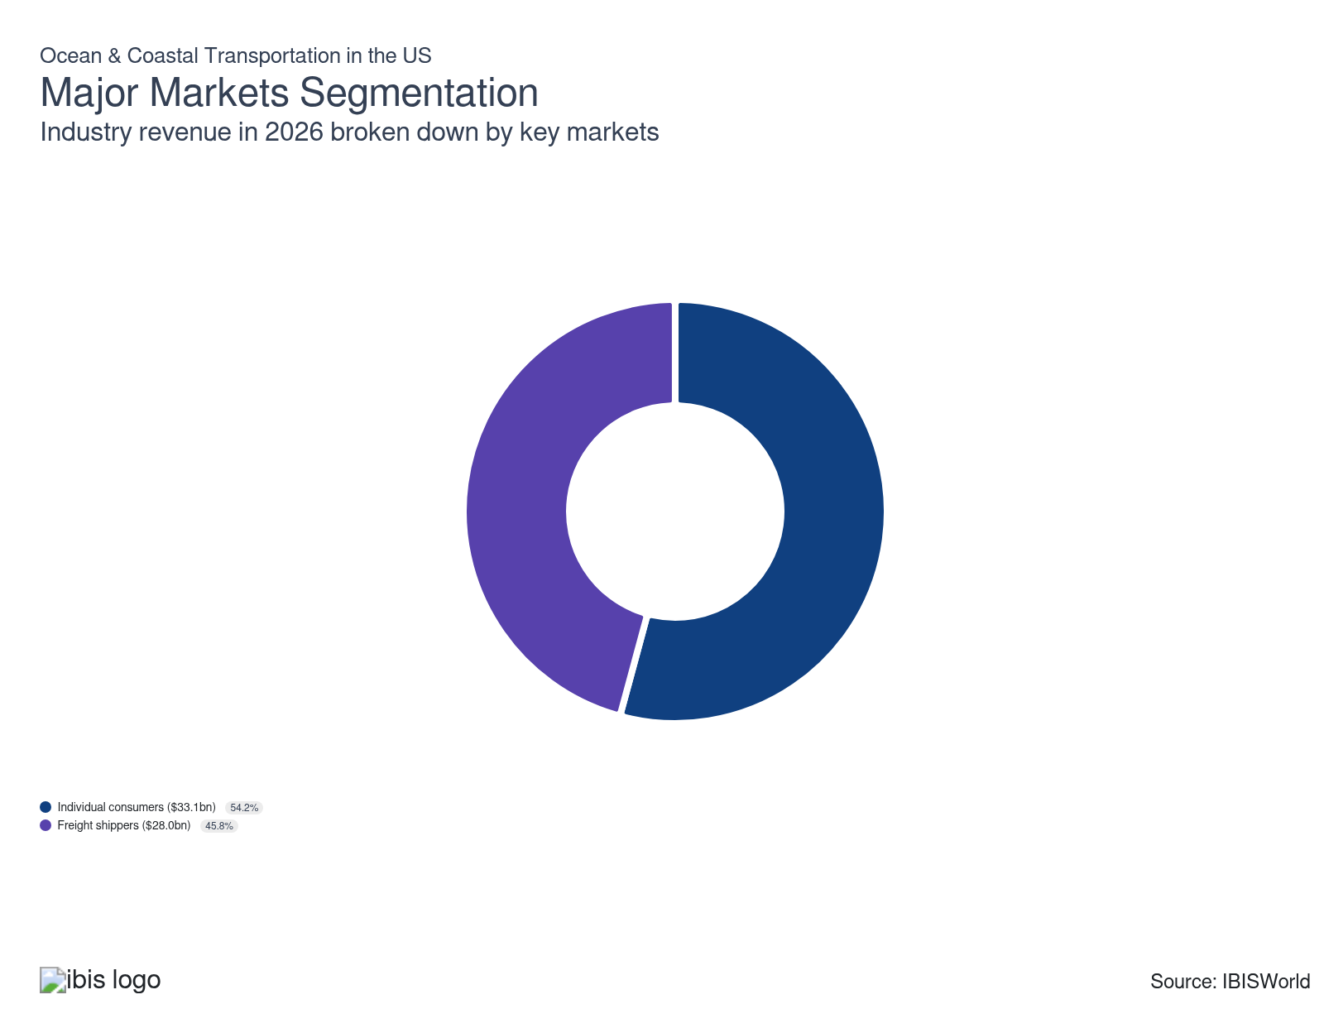

What’s influencing demand from the industry’s markets?

Affluent travelers drive cruise demand through increased summer vacation spending
- Cruise consumers are leisure travelers purchasing all-inclusive ocean vacations that bundle transportation, lodging, dining and entertainment. Each passenger generates substantial onboard and shoreside spending beyond the ticket price. This bundled-spend model makes cruises the highest-yield use of ocean vessels per traveler and captures the largest share of ocean-based leisure revenue compared to ferries or point-to-point passenger services.
- Demand growth reflects increased vacation spending by higher-income households. According to Deloitte, 44.0% of US travelers earning over $100,000 took vacations in Summer 2024, compared to 35.0% in 2023. Deloitte also noted that wealthier travelers shifted their preference toward cruise trips during this period. Norwegian confirmed these trends, reporting that its luxury brands generated nearly 20.0% year-over-year booking growth in Q3 2025, underscoring that affluent consumers are driving market expansion.

Container shipping faces margin pressure from excess capacity despite trade growth
- Container shipping companies move standardized boxes of manufactured goods for retailers, manufacturers and ecommerce brands. This segment captures a substantial but non-dominant share of freight revenue, as high-value consumer goods travel in containers while heavier raw materials move on bulk carriers. Container lines specialize in time-sensitive, scheduled services linking global gateways, positioning them as a "second pillar" of ocean freight revenue alongside bulk and tanker operators.
- Trade grew during the period, but excess capacity pressured shipping rates and revenue. The Shanghai Container Freight Index (SCFI), which tracks regional routes from Shanghai, fell to 1,600 by December 2025 from 4,900 in December 2021. According to Doug Hansen, global director of commercial consulting for Moffatt & Nichol, the supply-demand gap for shipping capacity widened in 2024, limiting carriers' ability to raise spot rates despite a recovery in trade volumes and constraining revenue gains.

International Trade

Some industries don't directly import or export goods. See reports at the manufacturing level for international trade data on relevant products.

5. Geographic Breakdown
https://my.ibisworld.com/us/en/industry/48311/geographic-breakdown

Key Takeaways
- Florida’s cruise clusters make the Southeast the industry’s epicenter. Dense homeport infrastructure in Miami, Port Everglades and Tampa, plus record bookings at Carnival and Royal Caribbean, lock in establishment growth well beyond the state’s economic weight.
- West Coast and Alaska play very different maritime roles. California and Washington lean toward container gateways and terminal infrastructure, while Alaska relies on Jones Act-protected coastal trades and seasonal cruises to sustain a surprisingly dense maritime footprint.

Business Locations
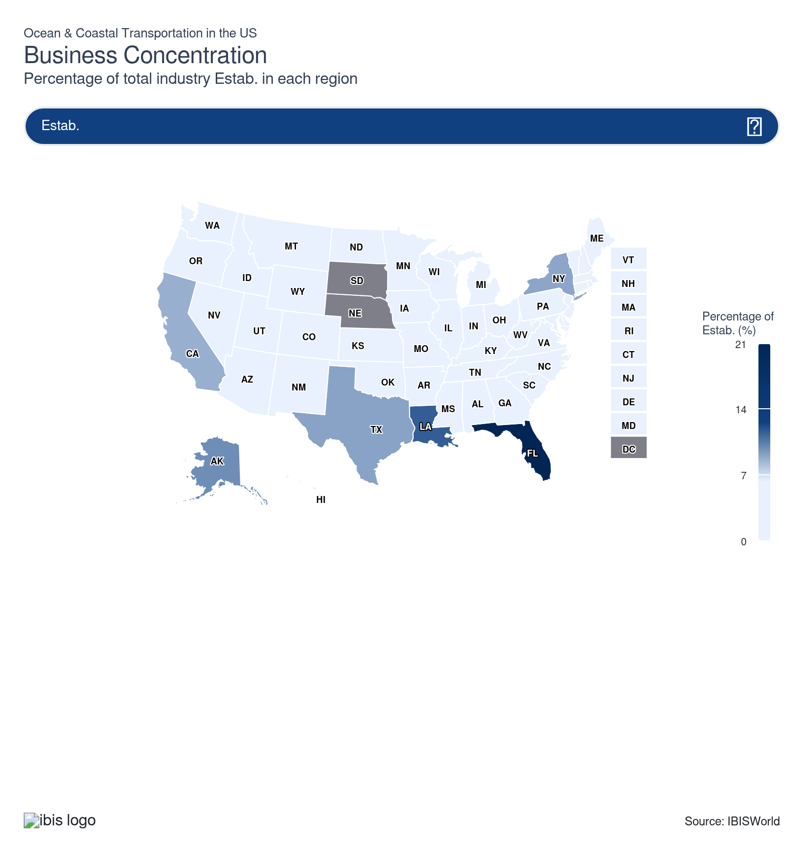
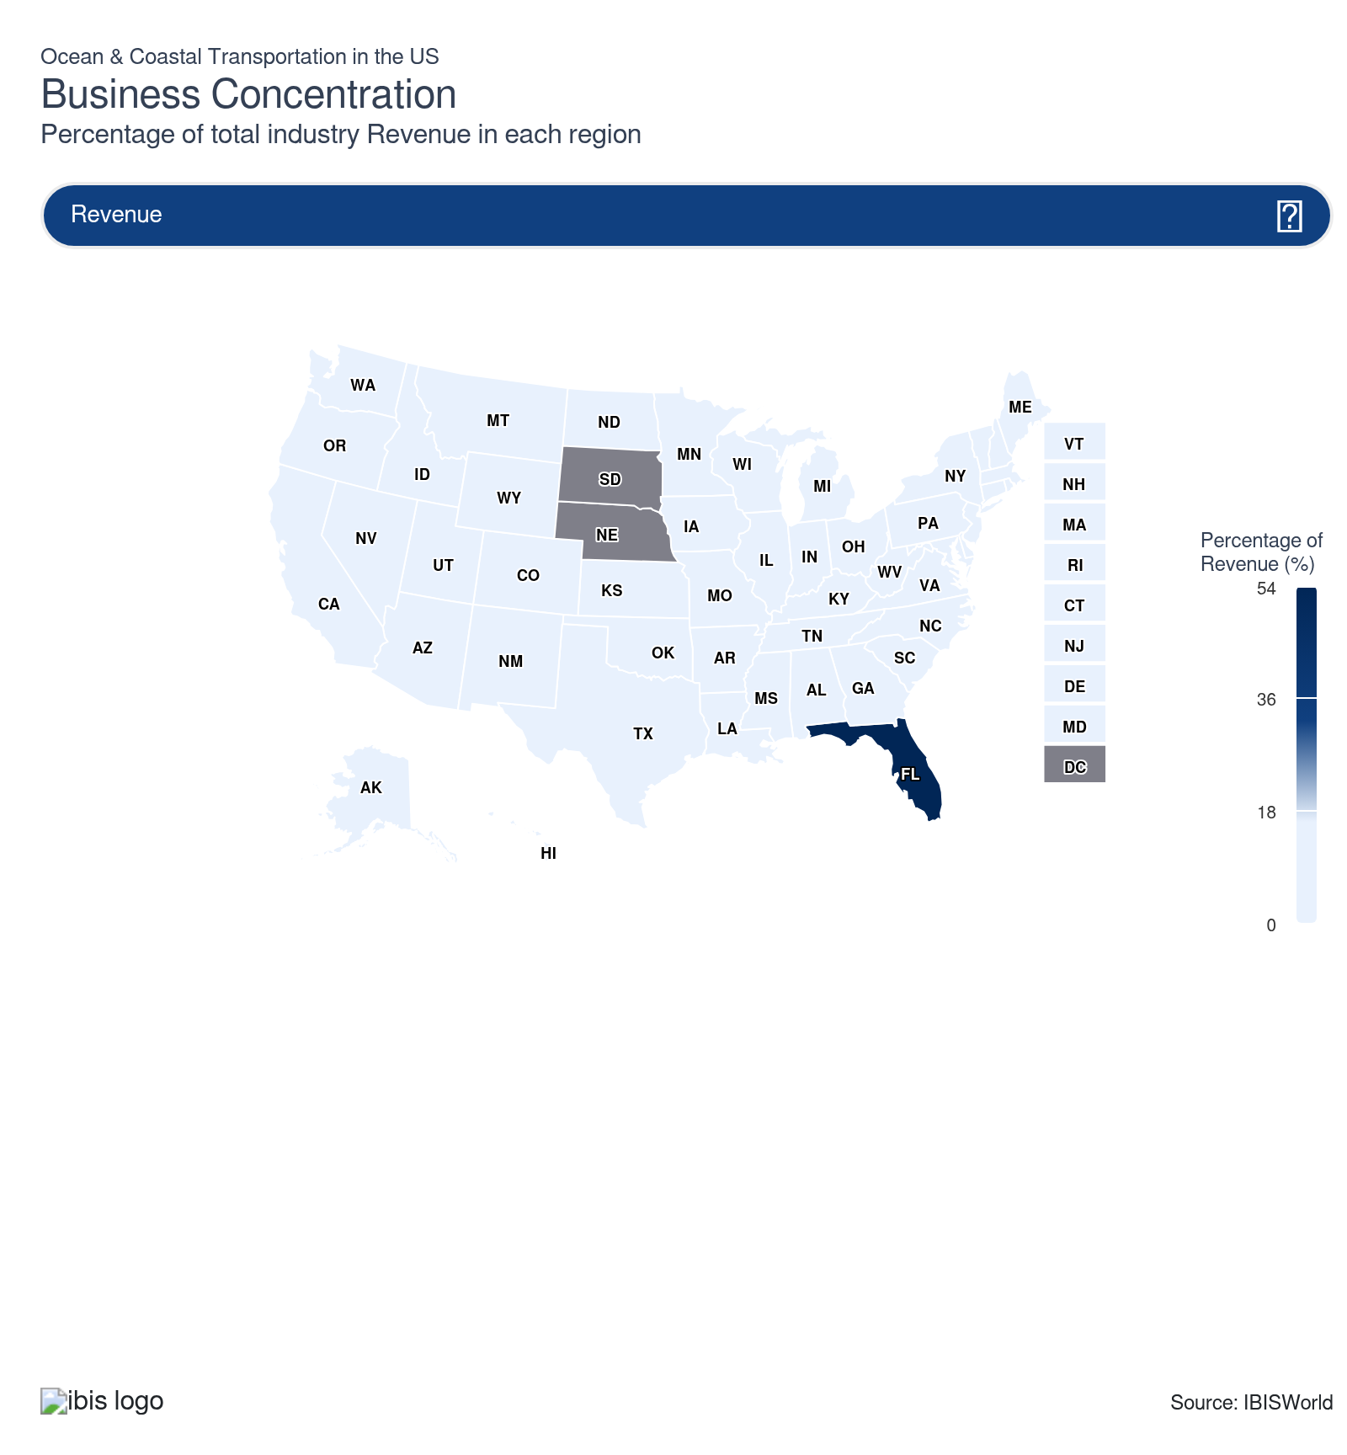
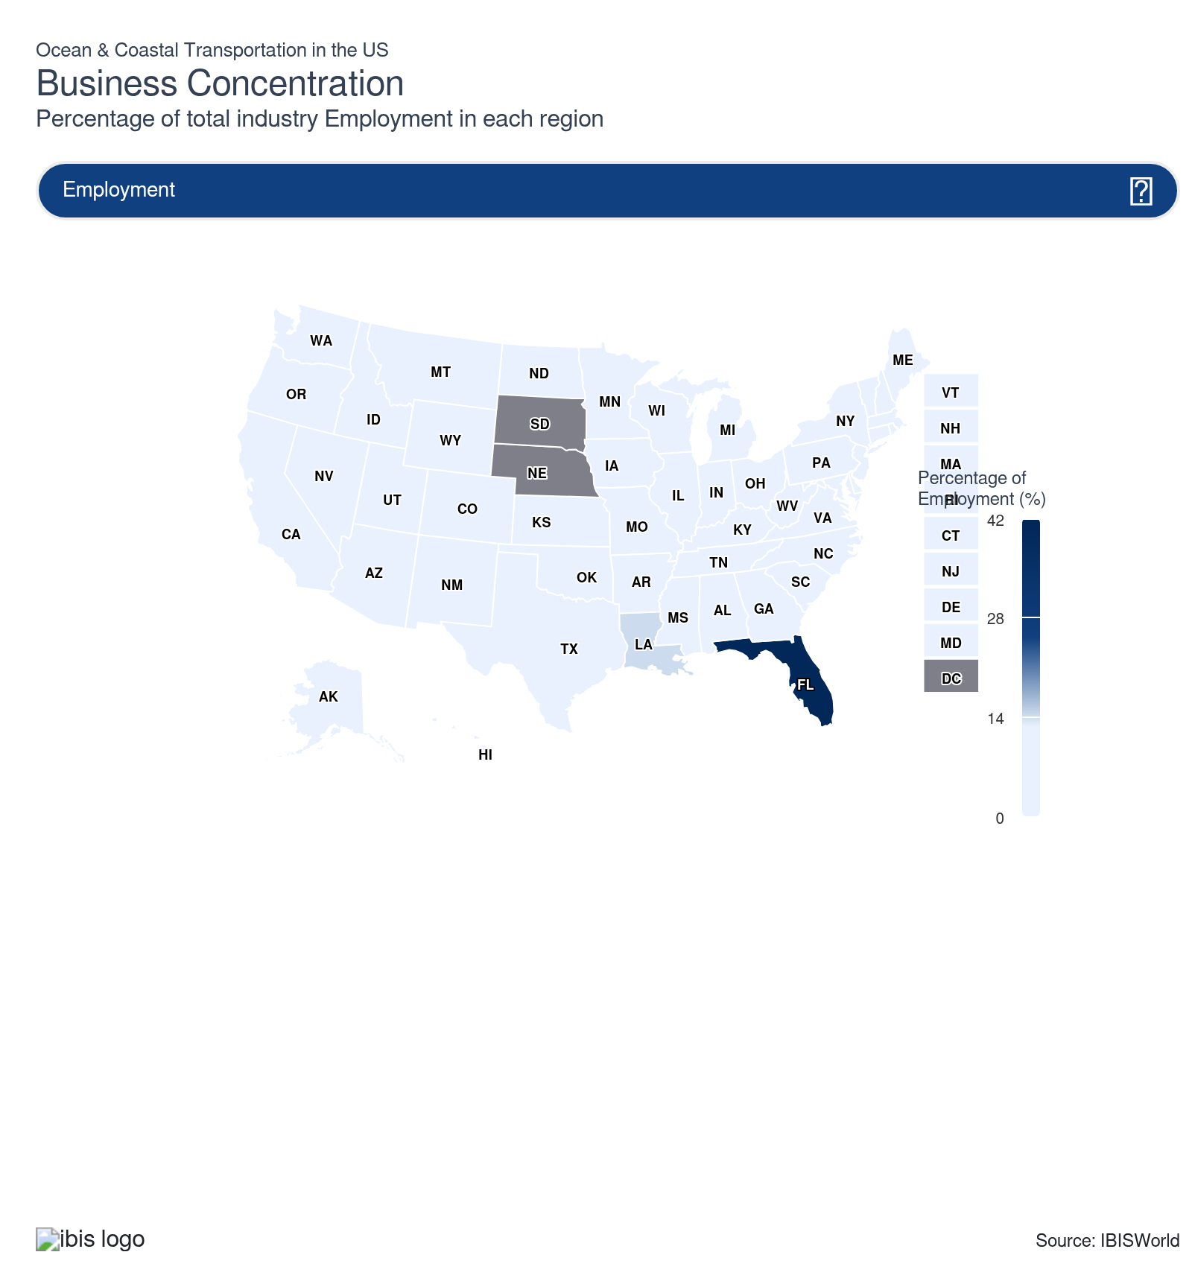
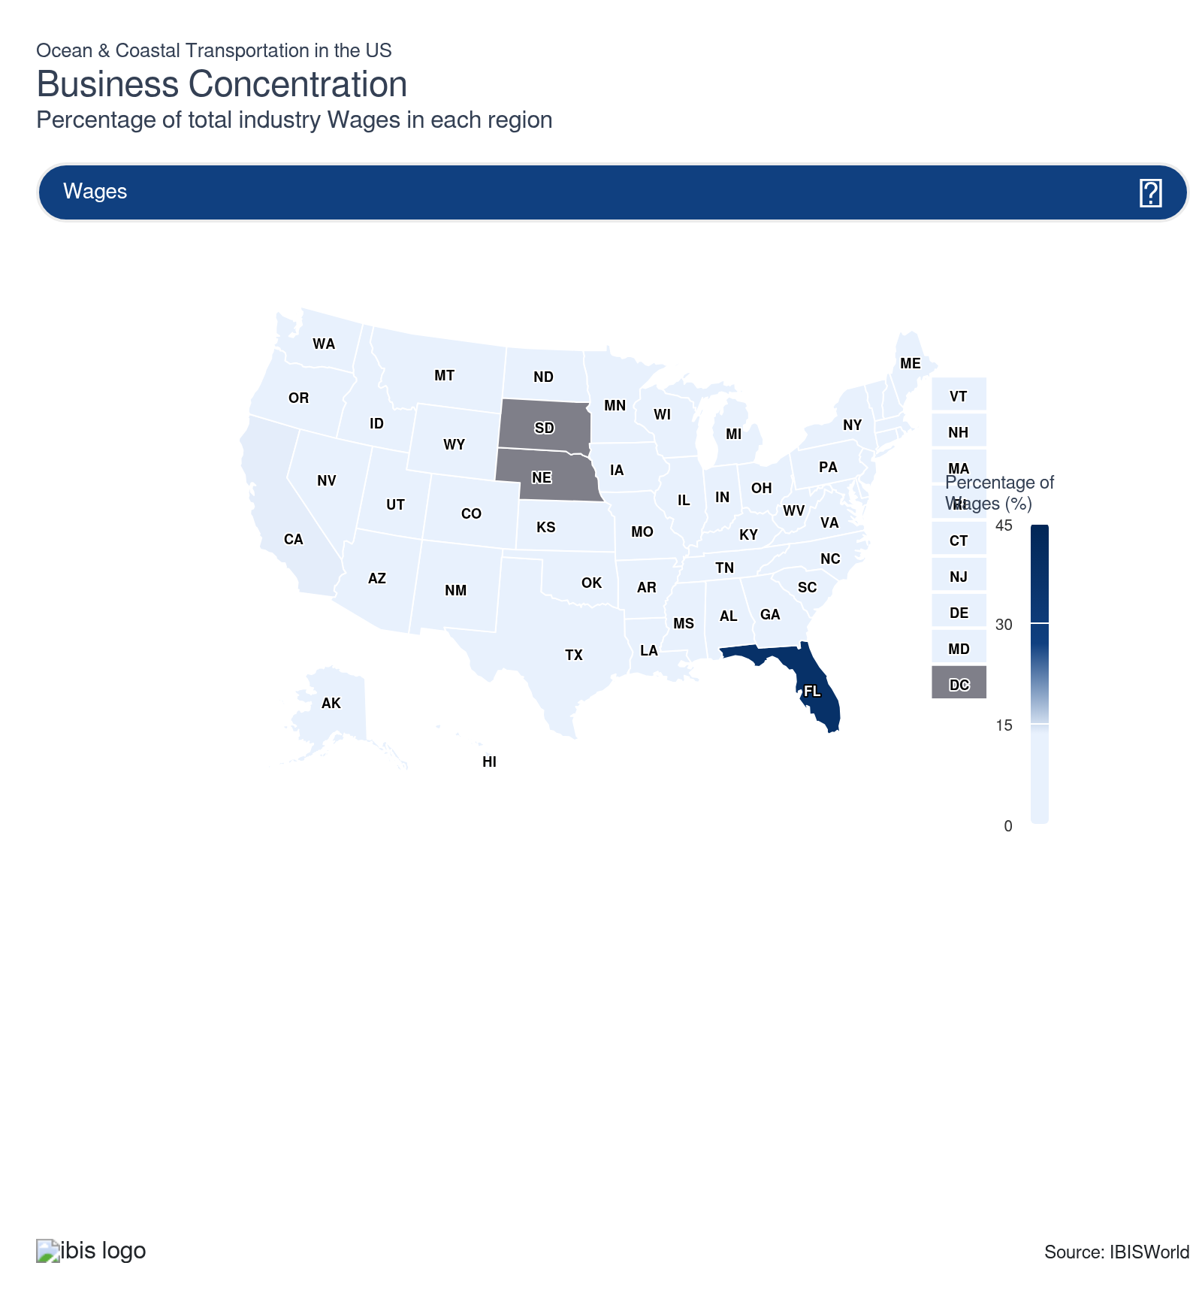
State | Estab.  Units | Estab.  % | Revenue  $m | Revenue  % | Wages  $m | Wages  % | Employment  Units | Employment  % | Population  %
Florida | 242 | 20.9 | 33,056.0 | 54.1 | 2,104.6 | 37.4 | 18,286 | 40.6 | 7.0
California | 100 | 8.6 | 8,905.9 | 14.6 | 775.8 | 13.8 | 5,546 | 12.3 | 11.5
Louisiana | 134 | 11.6 | 2,433.4 | 4.0 | 553.7 | 9.8 | 6,384 | 14.2 | 1.3
Washington | 68 | 5.9 | 3,635.1 | 6.0 | 497.3 | 8.8 | 4,150 | 9.2 | 2.3
Alaska | 114 | 9.9 | 1,419.5 | 2.3 | 131.3 | 2.3 | 1,296 | 2.9 | 0.2
Texas | 105 | 9.1 | 2,417.9 | 4.0 | 463.3 | 8.2 | 3,359 | 7.4 | 9.4
New York | 104 | 9.0 | 2,422.1 | 4.0 | 345.7 | 6.1 | 2,322 | 5.1 | 5.8
Virginia | 31 | 2.7 | 2,310.4 | 3.8 | 189.3 | 3.4 | 1,472 | 3.3 | 2.6
Hawaii | 14 | 1.2 | 622.1 | 1.0 | 125.1 | 2.2 | 2,156 | 4.8 | 0.4
New Jersey | 47 | 4.1 | 714.1 | 1.2 | 135.5 | 2.4 | 1,057 | 2.3 | 2.8
Connecticut | 23 | 2.0 | 827.3 | 1.4 | 147.1 | 2.6 | 1,039 | 2.3 | 1.1
Massachusetts | 31 | 2.7 | 263.0 | 0.4 | 83.6 | 1.5 | 473 | 1.0 | 2.1
Michigan | 28 | 2.4 | 391.9 | 0.6 | 76.3 | 1.4 | 526 | 1.2 | 3.0
Illinois | 18 | 1.6 | 373.2 | 0.6 | 23.4 | 0.4 | 260 | 0.6 | 3.7
Georgia | 22 | 1.9 | 152.3 | 0.2 | 12.5 | 0.2 | 143 | 0.3 | 3.3
Ohio | 10 | 0.9 | 265.1 | 0.4 | 60.1 | 1.1 | 500 | 1.1 | 3.5
Maryland | 21 | 1.8 | 287.9 | 0.5 | 66.4 | 1.2 | 462 | 1.0 | 1.8
Oregon | 13 | 1.1 | 222.5 | 0.4 | 66.7 | 1.2 | 489 | 1.1 | 1.2
Pennsylvania | 18 | 1.6 | 88.2 | 0.1 | 39.0 | 0.7 | 277 | 0.6 | 3.8
Minnesota | 8 | 0.7 | 244.7 | 0.4 | 58.8 | 1.0 | 219 | 0.5 | 1.7
North Carolina | 12 | 1.0 | 33.5 | 0.1 | 15.4 | 0.3 | 164 | 0.4 | 3.3
Tennessee | 6 | 0.5 | 102.1 | 0.2 | 10.6 | 0.2 | 105 | 0.2 | 2.1
Rhode Island | 10 | 0.9 | 19.9 | 0.0 | 2.5 | 0.0 | 31 | 0.1 | 0.3
Delaware | 9 | 0.8 | 71.4 | 0.1 | 10.6 | 0.2 | 94 | 0.2 | 0.3
Alabama | 9 | 0.8 | 20.7 | 0.0 | 7.6 | 0.1 | 71 | 0.2 | 1.5
South Carolina | 9 | 0.8 | 41.1 | 0.1 | 3.6 | 0.1 | 55 | 0.1 | 1.6
Kentucky | 3 | 0.3 | 36.7 | 0.1 | 7.7 | 0.1 | 100 | 0.2 | 1.3
Indiana | 4 | 0.3 | 39.1 | 0.1 | 2.6 | 0.0 | 28 | 0.1 | 2.0
Mississippi | 4 | 0.3 | 8.4 | 0.0 | 4.2 | 0.1 | 94 | 0.2 | 0.9
New Mexico | 7 | 0.6 | 4.8 | 0.0 | 0.4 | 0.0 | 10 | 0.0 | 0.6
Arizona | 3 | 0.3 | 31.6 | 0.1 | 0.3 | 0.0 | 7 | 0.0 | 2.2
Colorado | 4 | 0.3 | 29.2 | 0.0 | 0.2 | 0.0 | 4 | 0.0 | 1.8
Missouri | 5 | 0.4 | 16.6 | 0.0 | 1.4 | 0.0 | 9 | 0.0 | 1.8
Wisconsin | 4 | 0.3 | 11.6 | 0.0 | 3.1 | 0.1 | 23 | 0.1 | 1.7
Wyoming | 4 | 0.3 | 0.8 | 0.0 | 0.1 | 0.0 | 10 | 0.0 | 0.2
Idaho | 3 | 0.3 | 13.1 | 0.0 | 1.8 | 0.0 | 28 | 0.1 | 0.6
Nevada | 3 | 0.3 | 18.2 | 0.0 | 0.1 | 0.0 | 3 | 0.0 | 1.0
Maine | 3 | 0.3 | 5.4 | 0.0 | 1.5 | 0.0 | 27 | 0.1 | 0.4
New Hampshire | 2 | 0.2 | 10.7 | 0.0 | 1.8 | 0.0 | 18 | 0.0 | 0.4
Kansas | 2 | 0.2 | 11.8 | 0.0 | 1.6 | 0.0 | 20 | 0.0 | 0.9
Utah | 2 | 0.2 | 12.1 | 0.0 | 1.7 | 0.0 | 20 | 0.0 | 1.0
Iowa | 2 | 0.2 | 11.6 | 0.0 | 1.5 | 0.0 | 19 | 0.0 | 0.9
Arkansas | 2 | 0.2 | 10.3 | 0.0 | 1.4 | 0.0 | 19 | 0.0 | 0.9
Oklahoma | 2 | 0.2 | 10.8 | 0.0 | 1.3 | 0.0 | 19 | 0.0 | 1.2
Vermont | 2 | 0.2 | 4.9 | 0.0 | 0.8 | 0.0 | 14 | 0.0 | 0.2
North Dakota | 2 | 0.2 | 7.9 | 0.0 | 0.9 | 0.0 | 15 | 0.0 | 0.2
Montana | 2 | 0.2 | 5.1 | 0.0 | 0.6 | 0.0 | 11 | 0.0 | 0.3
West Virginia | 2 | 0.2 | 8.0 | 0.0 | 0.9 | 0.0 | 17 | 0.0 | 0.5

Where are industry businesses located?

Florida's cruise homeporting concentration drives Southeast dominance
- Because major cruise homeports cluster in South Florida, the state holds 22.5% of all industry establishments, the largest share of any state, anchored by three of the world's busiest passenger vessel terminals at Miami, Port Everglades and Tampa. This concentration is self-reinforcing: the infrastructure required to turn around large cruise ships (provisioning logistics, crew accommodation networks, shoreside maintenance facilities) creates deep switching costs that bind homeport selection decisions to existing clusters. Florida's year-round warm climate removes the seasonal operating constraints that limit northern ports, extending effective vessel utilization relative to Northeast or Pacific Northwest alternatives.
- Across Miami, Port Everglades and Tampa, the dominant demand driver is not freight but passenger volume at cruise lines' highest density. Florida's Southeast coastline accounts for the majority of Carnival Corporation's and Royal Caribbean Group's North American homeport capacity. Both operators are deploying record volumes from these terminals: Carnival sold approximately 85.0% of 2026 capacity at historically high prices by early 2026 and Royal Caribbean reported that approximately two-thirds of its 2026 capacity was booked at record rates, per Q1 2026 earnings disclosures from both companies. This forward demand pipeline translates directly into sustained establishment density, as terminal operators, crew logistics providers and shoreside contractors scale to serve peak-season turnarounds.
- Reinforced by these record-breaking volumes, Florida's position as the Southeast's dominant maritime hub is diverging further from national norms. Louisiana (8.3% of establishments) adds a second Southeast cluster, driven by Gulf Coast petroleum shipping rather than passenger operations and together the two states account for approximately 30.8% of all industry establishments in the Southeast region. Virginia (3.0%) rounds out the Southeast's contribution, primarily through naval port infrastructure at Norfolk that supports coastal and coastal-adjacent operations. The Southeast's combined ~33.8% share reflects an industry-specific concentration that far exceeds the region's general economic weight, driven by a combination of cruise homeporting demand in Florida and energy-related coastal freight in Louisiana.

West Coast and Alaska operations serve two systematically distinct sub-segments
- California hosts the San Pedro Bay complex of Los Angeles and Long Beach, the largest container gateway in the Western Hemisphere, and its ocean and coastal transportation establishments largely reflect deep-sea container operations, agencies and terminal infrastructure rather than the head offices of global liner operators. Alaska, by contrast, is dominated by a Jones Act-protected domestic cargo and passenger market, where U.S.-flag vessels move freight between Alaska and the Lower 48 and where seasonal cruise traffic generates outsized passenger volumes relative to the state’s population. Washington’s Seattle–Tacoma complex serves as the main Pacific Northwest coastal cargo hub, a key origin point for Alaska ferries and cruises, and an important transpacific container gateway.
- Against that backdrop, CMA CGM has announced a 20-billion-dollar, four-year investment plan in U.S. maritime and logistics capacity, including 4 billion dollars earmarked for ports and explicit commitments to infrastructure in New York, Los Angeles, Dutch Harbor, Houston and Miami. That level of port-focused capital, layered on top of CMA CGM’s full ownership of the Fenix Marine Services terminal in Los Angeles and its new United Ports LLC terminal joint venture, signals that major operators still view the U.S. West Coast gateway system as a long-term strategic asset despite short-run swings in volume.
- Along Alaska’s coastline, U.S. cabotage rules require that commercial cargo shipped between Alaskan and Lower 48 ports move on U.S.-built, U.S.-owned, U.S.-flag, and primarily U.S.-crewed vessels, effectively creating a captive domestic market that supports dedicated U.S.-flag fleets instead of globally routed foreign-flag vessels. This framework helps sustain a denser maritime establishment base than Alaska’s economic size alone might suggest.

Gulf Coast hubs link tank barge freight with emerging cruise demand
- Enterprises cluster in the Gulf Coast energy corridor because it sits near Gulf of Mexico oil and gas production, Gulf Coast refining capacity and large petrochemical complexes, which together generate steady demand for coastal tank barge movements. Texas accounts for about 9.5% of industry establishments and Louisiana for 8.3%, and operators in these states primarily serve refineries, petrochemical terminals and industrial shippers rather than leisure markets.
- Companies such as Kirby concentrate operations along this corridor, with key facilities from Channelview to Corpus Christi, to stay close to liquid bulk customers and major terminal infrastructure. This network reflects how proximity to deepwater ports, pipeline connections and storage capacity shapes the geography of coastal tank barge activity.
- At the same time, Texas is strengthening its role in cruising, as brands shift capacity toward Gulf ports to capture drive-to demand and diversify homeport options. MSC Cruises began sailing from Galveston to the Western Caribbean in 2025. They agreed to a long-term arrangement with Galveston Wharves to finance a new terminal, which was later opened in 2025, signaling how port investments support the region’s dual role as an energy and cruise hub.
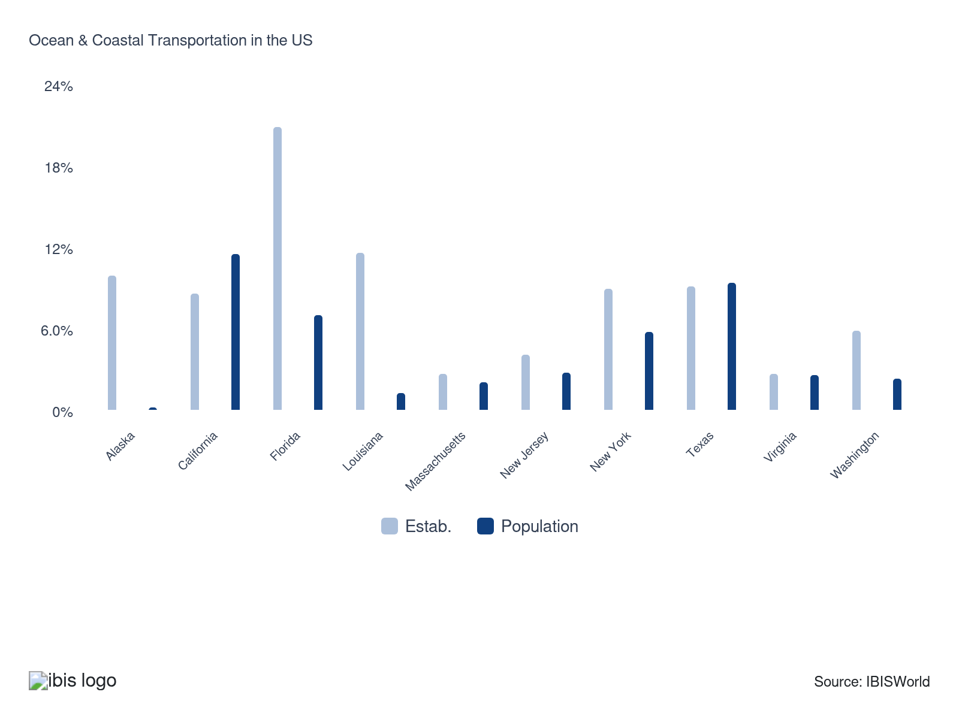

How do businesses use location to their advantage?
Operate in a location that is close to key markets
Florida-based cruise operators homeport vessels within driving distance of the densest domestic passenger catchment area in the United States. The Southeast's concentration of retirees, leisure travelers, and accessible interstate infrastructure allows same-day boarding without the overnight travel required for non-Florida homeports, reducing the price barrier for cruise participation and supporting higher load factors than demographically comparable facilities in other regions.
Operate in a location that is close to key suppliers
Gulf Coast tank barge carriers locate operations at the intersection of petrochemical production and refinery output, allowing just-in-time cargo pickup from production terminals without the deadhead repositioning cost that inland or northern operators would incur. Kirby's Gulf Coast terminal network minimizes empty barge miles by co-locating loading and unloading berths with the primary chemical and petroleum producers it serves along the Houston Ship Channel and Mississippi River corridor.

6. Competitive Forces
https://my.ibisworld.com/us/en/industry/48311/competitive-forces

Key Takeaways
- Carrier alliances now dominate the busiest freight lanes. By coordinating capacity and routes, a handful of alliance groups control most Asia–North America cargo, leaving independents to fight over a small slice of remaining volume.
- Cruises fight land vacations by selling exclusivity, not just price. As more travelers weigh all-inclusive resorts against entry-level cruises, big lines like Royal Caribbean are betting on private islands and branded beach clubs to keep customers on board.

Concentration
Moderate
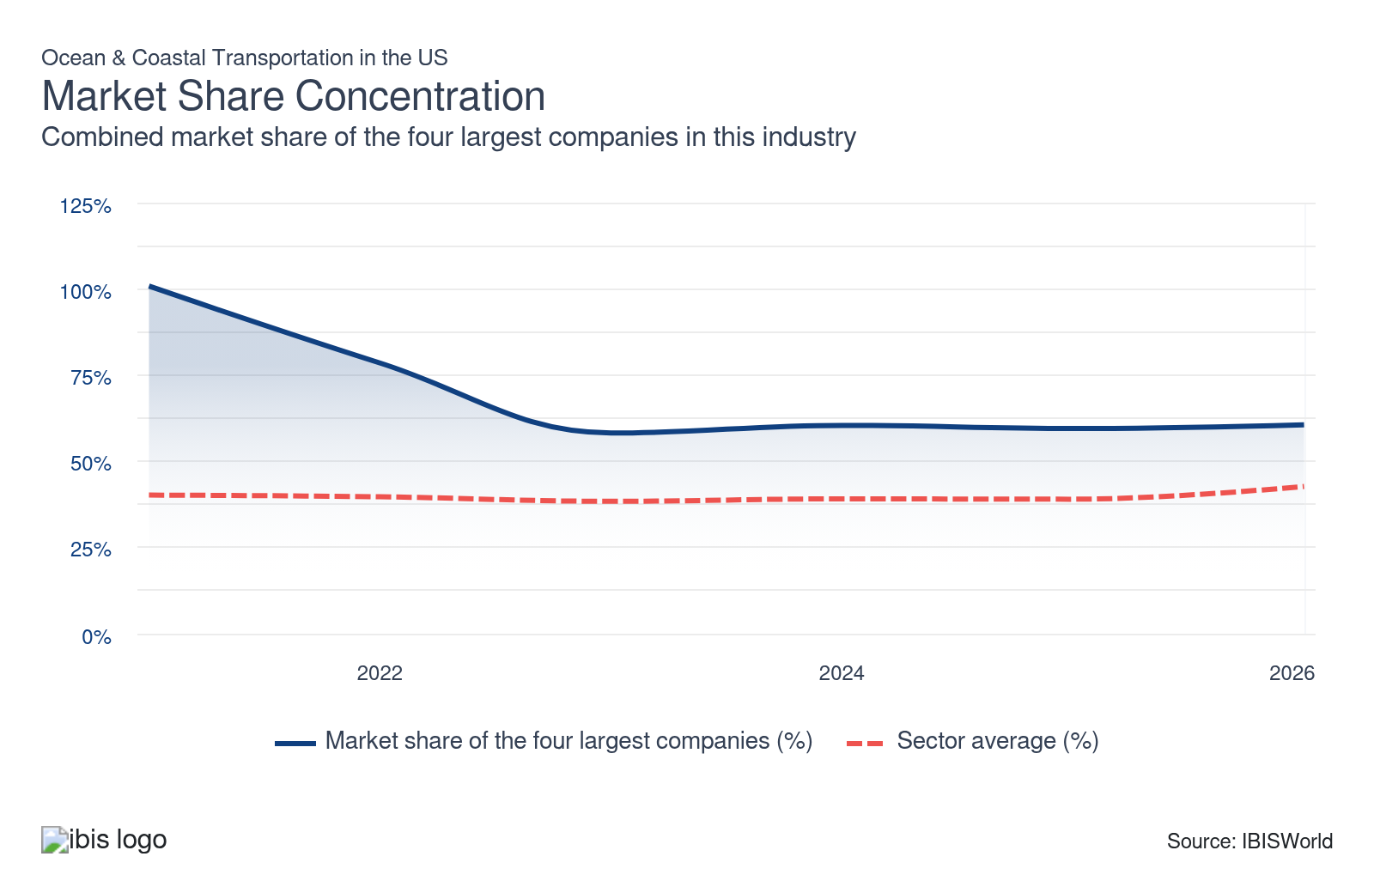

What impacts the industry’s market share concentration?

Carrier alliances concentrate freight market power on major Asia-North American routes
- Freight transportation concentration stems from reliance on carrier alliances that pool vessel capacity and operational resources. Major carriers like Maersk and Hapag-Lloyd participate in alliances that share container ship capacity to optimize costs and manage maritime traffic. These collaborative structures consolidate market power among alliance members than individual companies, creating barriers for non-alliance carriers. Alliance restructuring in 2025 rearranged partnerships but maintained the fundamental concentration model, concentrating shipping capacity in the hands of a few major alliance groups.
- Alliance dominance is particularly pronounced on key trade routes. According to Flexport, reformed alliances control 80.0% of cargo shipments on Asia–North American routes as of 2025, leaving only 12.8% for independent or non-alliance carriers. This concentration disparity limits capacity access for smaller operators and reinforces competitive advantages for alliance members through shared vessel deployments, route optimization and cost efficiencies. The alliance structure creates structural barriers that smaller carriers struggle to overcome.

Dominant mass market brands drive cruise concentration on select routes
- Market share in ocean cruising is concentrated among a few mass-market brands, including Carnival, Royal Caribbean, Norwegian and the growing MSC Cruises, which deploy large ships and secure preferred berths or private destinations on marquee routes. These advantages in capacity, access and marketing make it difficult for smaller or newer operators to gain scale on popular itineraries.
- CLIA reports that Caribbean/Bahamas/Bermuda itineraries remain the most popular cruise region, ahead of Mediterranean and European routes, so major brands prioritize these markets. Bermello Ajamil indicated in 2024 that contemporary or mass-market lines account for about 86.0% of Caribbean deployment, leaving only a small share for luxury and niche operators, which concentrates value on large mainstream brands and reinforces high market share concentration.

Loyalty programs and repeat customers entrench major cruise operators' market dominance
- Strong brand recognition and established loyalty programs create significant barriers for smaller cruise operators. Major cruise lines like Royal Caribbean report that repeat guests comprise 40.0% of their passenger base and generate 25.0% higher spending than first-time cruisers. This repeat customer base provides predictable revenue streams. It reduces customer acquisition costs, enabling large operators to reinvest in fleet expansion and marketing while smaller competitors struggle to build comparable loyalty infrastructure and brand awareness.
- Repeat customer concentration reinforces market share advantages for dominant cruise operators. The high spending differential between repeat and first-time passengers creates a valuable revenue segment that larger operators can capture and retain through established loyalty programs and vessel familiarity. This dynamic limits growth opportunities for independent or emerging cruise companies, as a significant portion of available cruise demand flows to established brands with proven track records and customer loyalty, widening competitive gaps and increasing industry concentration.

How do successful businesses handle concentration?
Leverage the degree of vertical integration within the company
Carriers that control both vessel capacity and terminal infrastructure — as MSC's Hutchison Ports acquisition illustrates — capture a larger share of the cargo revenue chain and reduce dependence on third-party port carriers. In the cruise segment, private destination development by Royal Caribbean and Carnival serves the same function, capturing onboard and destination spending that would otherwise flow outside the carriers' revenue structures.
Optimize operating capacity
Sustained utilization at or near full capacity, as demonstrated by Kirby's coastal barge operations and the major cruise lines' occupancy above 100%, is the clearest financial signal of competitive positioning. Carriers that maintain high utilization through cycle management — disciplined capacity additions, alliance coordination, or long-term contract structures — protect profit in ways that intermittently utilized fleets cannot.

Barriers to Entry
Moderate | Steady

What challenges do potential industry entrants face?

Legal
- At the federal level, new entrants must secure US Coast Guard credentials, water transportation permits and vessel inspection approvals before carrying a single passenger or cargo unit. The Maritime Action Plan (February 2026) proposes port fees on foreign-built vessels, adding a cost layer for any entrant relying on non-US-built tonnage. For domestic coastal routes, the Jones Act requires US-built, US-crewed and US-owned vessels, a triad of requirements that takes years to satisfy.

Start-up Costs
- Vessel acquisition costs set the minimum viable funding threshold: new cruise ships are expensive, while dual-fuel container vessels now require comparable capital commitments, as Maersk's 2026 orders for 18,600-TEU vessels illustrate. Constrained by shipyard lead times of three to five years, a new entrant can't easily acquire capacity quickly. Chartering second-hand tonnage offers a lower entry point for niche coastal freight routes, though it limits scale and route options.

Differentiation
- Incumbent brand strength remains formidable in the cruise segment, where Carnival, Royal Caribbean and Norwegian benefit from decades of accumulated customer loyalty, high repeat booking rates and strong advance deposit levels. Although this concentration in cruising restricts meaningful entry opportunities, the coastal freight segment – particularly coastal tank barge services – presents a more accessible path for new operators, since route-specific demand and vessel specialization can support smaller players without placing them in direct competition with large cruise brands.

Capital Expenses
- Capital intensity is rated High in this industry, reflecting the dominance of vessel ownership and fleet maintenance costs. With depreciation accounting for 7.3% of revenue and wages at only 9.2% (well below the sector average of 28.5%), the entry cost profile is driven by asset acquisition rather than labor recruitment. A new entrant must match the fleet investment and port relationship infrastructure of established carriers before achieving competitive unit economics.

How can potential entrants overcome barriers to entry?
Ensure proper licensing
A new entrant that maps out all required federal, state and Coast Guard approvals before committing capital can compress the compliance timeline significantly and avoid the costly delays that arise when licensing gaps surface after initial investment.
Ensure ready access to investment funding
Given that vessel acquisition costs for new cruise ships are extensive, access to capital markets, Title XI loan guarantees, or established shipping group backing is the single most decisive factor separating viable entrants from aspirational ones.

Substitutes
Moderate | Steady

What are substitutes for industry services?

International Airlines
- Air cargo's competitive edge over ocean transport is narrow but consequential: it captures demand for high-value, lightweight and time-sensitive shipments where delivery speed outweighs the cost premium. Express air freight via carriers such as FedEx and UPS offers transit times of 1 to 3 days on routes where ocean transit can take weeks, making it the practical alternative for pharmaceuticals, electronics and urgent industrial parts.
- The substitution, however, is constrained to a specific cargo profile. Bulk commodities, liquid cargo and heavy industrial freight have no viable air equivalent given aircraft weight limits and per-unit economics.

General Freight Trucking (Truckload)
- Trucking is often more flexible for inland destinations, providing direct door-to-door service without additional port handling and maintenance that many on freight have to check off before departing. While more affordable than air freight, trucking costs vary widely based on fuel prices, driver availability and tolls and various external factors that are not in their control.
- Overland trucking has a higher carbon footprint per ton-mile than ocean freight, which is a factor that shapes whether companies want to prioritize sustainability in their operations. In contrast, cross-border trucking involves navigating many regulatory barriers while mounting fees and costs from tolls; a slowdown in traffic and bad weather can complicate logistics and raise potential delays.

Land-Based Resorts
- Land-based resort vacations and destination travel represent the primary substitute for cruise travel, competing directly for the same leisure budget among consumers who view a cruise as one option among many for a week-long vacation. This substitution threat is inherent to the industry's consumer revenue base (54.2% of total revenue, or $33.1 billion), which is driven predominantly by cruise passengers choosing ocean travel over hotels, theme parks, and land resorts. The substitute is most relevant at the entry-level cruise price tier, where all-inclusive resort packages can offer comparable pricing.
- In response to competition from land-based vacations, major cruise lines have deepened the experiential differentiation of their product so that substitution decisions hinge on more than price. Royal Caribbean Group is expanding its portfolio of owned and exclusive destinations—Perfect Day islands and Royal Beach Clubs—from two to eight locations by 2028, creating onshore experiences accessible only to its cruise guests.

How do successful businesses compete with substitutes?
Produce a differentiated product
Cruise operators insulate themselves from land-based travel substitution by investing in experiences that only a cruise can provide. Royal Caribbean's private destination expansion and Norwegian's luxury-segment offerings create product features that resort alternatives can't replicate, anchoring consumer preference regardless of relative price.
Develop a loyal customer base
Long-term contract structures bind freight customers to ocean and barge operators before spot modal comparisons become relevant. Contract renewals illustrate how sustained customer relationships and contracted capacity allocation reduce the effective substitution risk from trucking, even on routes where overland alternatives are technically viable.

Buyer & Supplier Power
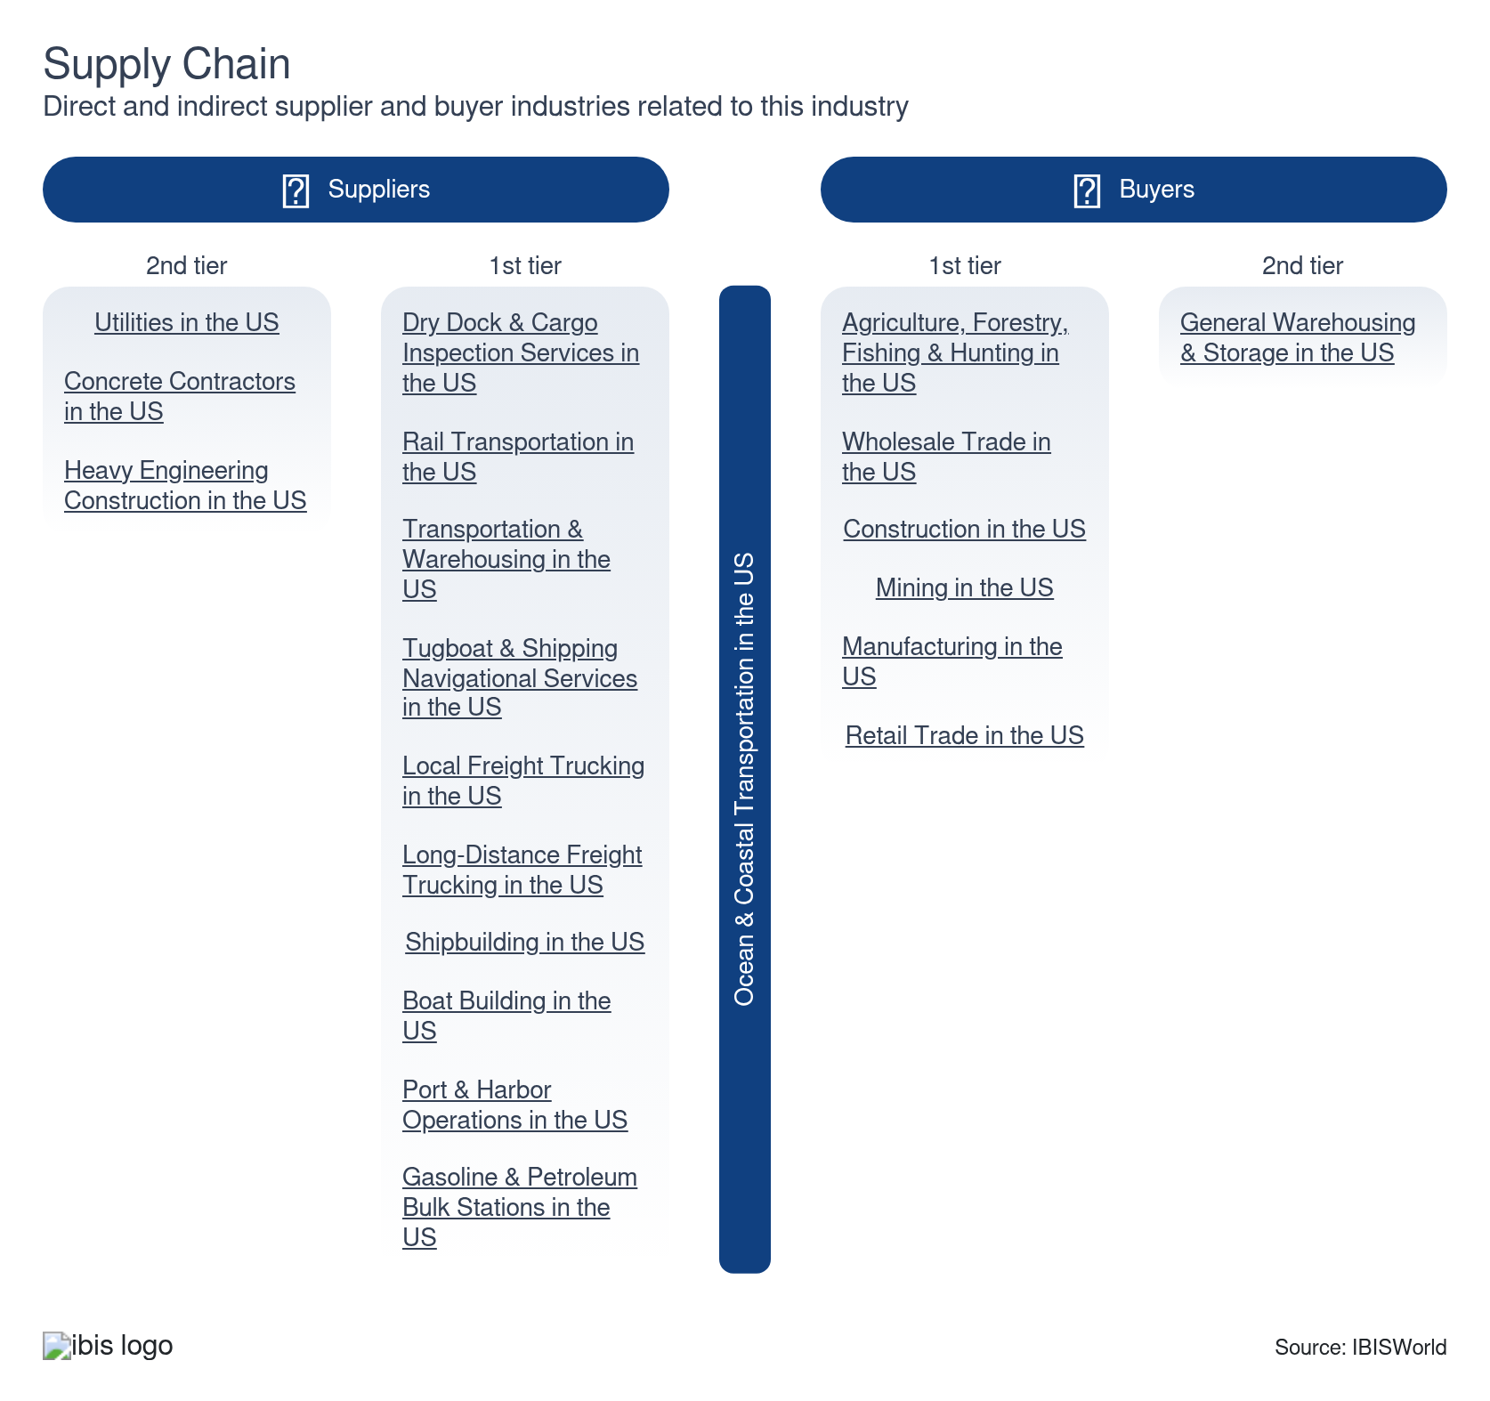

What power do buyers and suppliers have over the industry?

Buyers: Limited control over fuel-linked contracts
Moderate | Increasing
- Beneficial cargo owners BCOs gain some leverage from the range of carriers and services available on major trade lanes. Still, fragmented end markets mean few buyers can use their scale to consistently dictate contract terms. Even large retailers and manufacturers typically negotiate one-to-one with carriers rather than through highly concentrated buying groups, which keeps their bargaining power moderate.
- Contract structures further constrain buyer influence because base rates and surcharges often reference external fuel indices that neither carriers nor shippers control. When bunker costs rise, these index-linked mechanisms narrow pricing differences between carriers, limit shippers’ ability to play suppliers off against each other and reduce the benefit of switching, ultimately dampening buyer power.

Suppliers: Dispersed bunker market limits pricing power
Low | Steady
- Ocean carriers rely on bunker fuel, but the global bunker supply market remains fragmented, which constrains most suppliers’ influence over contract terms. As of 2026, Ship and Bunker reports that no single company controls more than 10.0% of bunker fuel sales and the largest participant, Bunker Holding, holds a 9.6% share, so carriers can usually switch to alternative suppliers if terms worsen.
- Suppliers gain more leverage when fuel markets face global disruptions, since they can pass higher input costs through to buyers via bunker surcharges and related fees. In these periods, carriers have limited short-term alternatives, so fuel cost spikes feed directly into voyage economics and compress profit despite the industry’s ability to shop across many bunker providers in normal conditions.

How do successful businesses manage buyer & supplier power?
Ensure prompt delivery to market
Providing timely deliveries can significantly reduce buyer complaints and enhance customer loyalty, diminishing buyer power. Consistent reliability builds trust and encourages long-term contracts, solidifying various companies' market positions.
Establish supply contracts for domestic sales
Securing more long-term supply contracts ensures a reliable revenue channel and helps positively keep supplier relationships. By locking in such agreements, companies mitigate risks from supply chain fluctuations, helping balance their supplier power.

7. Companies
https://my.ibisworld.com/us/en/industry/48311/companies

Key Takeaways
- AP Moller—Maersk Group is a major force in this industry. Having major shipping solutions that meet the high demands of international trade helps the company stay above water as one of the biggest companies in the industry.
- Hapag-Lloyd AG has a strong foothold because of its extensive international shipping network. Its strategic operations navigate tough competition, providing a quality service that's key in a competitive industry, helping it stand out more in a field with many companies like it.

Market Share
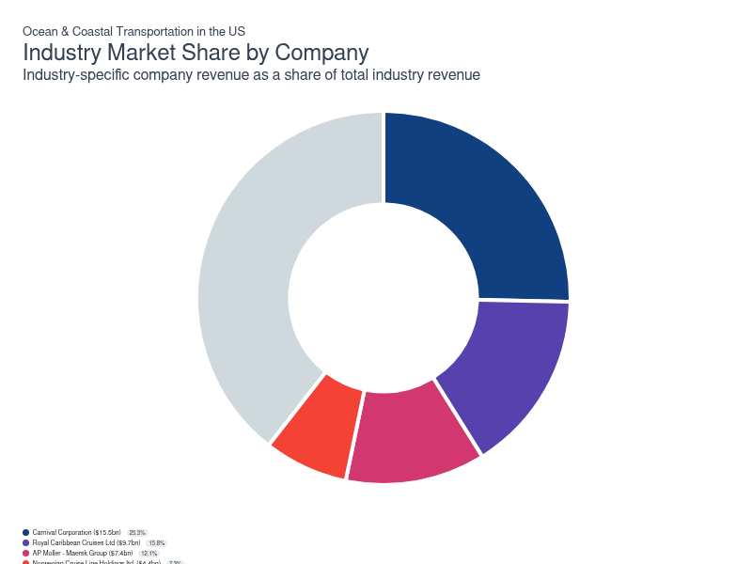
Chart displays current year only in the PDF version of this report. You can view and download chart for all other years associated with this industry on my.ibisworld.com.

Companies
Company | Market Share (%)  2026 | Revenue ($m)  2026 | Profit ($m)  2026 | Profit Margin (%)  2026
Carnival Corporation | 25.3 | 15,480.7 | 2,637.2 | 17.0
Royal Caribbean Cruises Ltd | 15.8 | 9,683.6 | 3,791.8 | 39.2
AP Moller - Maersk Group | 12.1 | 7,414.8 | 1,067.2 | 14.4
Norwegian Cruise Line Holdings ltd. | 7.3 | 4,440.9 | 818.7 | 18.4
Kirby Corporation | 5.7 | 3,465.9 | 426.3 | 12.3
Hapag-Lloyd AG | 5.6 | 3,398.8 | 524.7 | 15.4
CMA CGM Group | 4.6 | 2,793.0 | 396.5 | 14.2
MSC Mediterranean Shipping Company S.A. | N/A | N/A | N/A | N/A
Nippon Yusen Kabushiki Kaisha | N/A | N/A | N/A | N/A

Carnival Corporation
Carnival Corporation
Company Details
Company Details
Industry Specific Revenue (2026) | $15.5bn
Industry Profit (2026) | $2.6bn
Company Employees (2026) | 160,000
Market Share (2026) | 25.3%

Description
Description
Carnival is a public company headquartered in Florida with an estimated 160,000 employees. In the US, the company has a notable market share in at least one industry: Ocean & Coastal Transportation, where they account for an estimated 24.3% of total industry revenue and are considered an All Star because they display stronger market share, profit and revenue growth compared to their peers.

Brands and Trading Names
Brands and Trading Names
- AIDA Cruises
- Carnival Cruise Lines
- Costa Cruises
- Cunard Line
- Holland America Line
- P&O Cruises
- Princess Cruises
- Seabourn

Company’s Industry Revenue, Market Share, and Profit Margin Over Time
Company’s Industry Revenue, Market Share, and Profit Margin Over Time
Year | Industry Revenue ($ million) | Market Share (%) | Profit Margin (%)
2021 | 1060 | 5.0 | -371.5
2022 | 6760 | 16.0 | -36.0
2023 | 11996 | 23.3 | 9.1
2024 | 13901 | 24.5 | 14.3
2025 | 14790 | 25.1 | 16.8
2026 | 15481 | 25.3 | 17.0

What's impacting Carnival Corporation's performance?

Carnival subsidiary Seabourn participates in CDC’s updated program for cruise ships
- In February of 2022, Carnival’s subsidiary, Seabourn, a luxury cruise line, announced it will opt into the U.S. Centers for Disease Control and Prevention (CDC) updated program for cruise ships operating in the US. The ship will continue its normal vaccinated operation procedures, but will implement two key changes. The first change is that masks will be recommended but no longer required and the second adds additional flexibility for pre-cruise testing for all individuals. These new rules are effective starting March 1st, 2022.

Carnival Corporation Leveling up their Operations
- Expansions are underway for Carnival Corporation. In 2024, the company revealed it was ordering more ships to enjoin its cruise operations, which will be set to sail from 2029 into 2033. By ordering these ships, the company will be able to expand how many passengers it can serve, boosting its revenue sources in the period ahead.
Royal Caribbean Cruises Ltd
Royal Caribbean Cruises Ltd
Company Details
Company Details
Industry Specific Revenue (2026) | $9.7bn
Industry Profit (2026) | $3.8bn
Company Employees (2026) | 106,000
Market Share (2026) | 15.8%

Description
Description
Royal Caribbean Cruises is a public company headquartered in Florida with an estimated 106,000 employees. In the US, the company has a notable market share in at least one industry: Ocean & Coastal Transportation, where they account for an estimated 15.2% of total industry revenue and are considered an All Star because they display stronger market share, profit and revenue growth compared to their peers.

Brands and Trading Names
Brands and Trading Names
- Celebrity Cruises
- Royal Caribbean
- Silversea Cruises

Company’s Industry Revenue, Market Share, and Profit Margin Over Time
Company’s Industry Revenue, Market Share, and Profit Margin Over Time
Year | Industry Revenue ($ million) | Market Share (%) | Profit Margin (%)
2021 | 766 | 3.6 | -252.6
2022 | 4420 | 10.5 | 8.0
2023 | 6950 | 13.5 | 32.7
2024 | 8242 | 14.5 | 36.2
2025 | 8859 | 15.0 | 38.5
2026 | 9684 | 15.8 | 39.2

What's impacting Royal Caribbean Cruises Ltd's performance?

Royal Caribbean Group selling its Azamara brand to Sycamore Partners
- On January 19, 2021, Royal Caribbean Group agreed with private equity firm Sycamore Partners to sell its Azamara brand to them. The Azamara brand was Royal Caribbean's cruise line based in Florida. Royal Caribbean Group's decision to sell Azamara comes at a time when the company is restructuring and refocusing its efforts on its three main brands: Royal Caribbean International, Celebrity Cruises, and Silversea. The company has also undergone financial hardships due to the COVID-19 (coronavirus) pandemic impacting demand for cruise lines and leading to the company suspending its own operations throughout 2020 and into 2021.

Royal Caribbean Cruises levels up with fleet expansions
- The company has been making various moves to expand its operations. In 2022, Royal Caribbean announced it bought the cruise Endeavor for over $270.0 million. An acquisition like this will help the company generate value by having many more passengers, boosting the number of tickets it can sell now.

Royal Caribbean Group to purchase remaining shares of Silversea cruiselines
- On July 10, 2020, Royal Caribbean Group acquired the rest of the shares of Silversea Cruises, a luxury cruise line. The company will now have full ownership of the company after having a one-third stake in the company in the past. The companies move to acquire the company comes at a turbulent time in the industry with the COVID-19 (coronavirus) pandemic impacting demand and revenue for cruise lines globally, as the decision to acquire brands such as Silversea helps the company grow and consolidate its share of the luxury cruise market so when the economy reopens again the company will see higher growth overall.
AP Moller - Maersk Group
AP Moller - Maersk Group
Company Details
Company Details
Industry Specific Revenue (2026) | $7.4bn
Industry Profit (2026) | $1.1bn
Company Employees (2026) | 100,000
Market Share (2026) | 12.1%

Description
Description
AP Moller - Maersk is a public company with an estimated 100,000 employees. In the US, the company has a notable market share in at least two industries: Heating & Air-Conditioning Equipment Manufacturing, Ocean & Coastal Transportation and Heating & Air-Conditioning Equipment Manufacturing. Their largest market share is in the Ocean & Coastal Transportation industry, where they account for an estimated 11.6% of total industry revenue.

Other Industries
Other Industries
- Heating & Air-Conditioning Equipment Manufacturing in the US

Company’s Industry Revenue, Market Share, and Profit Margin Over Time
Company’s Industry Revenue, Market Share, and Profit Margin Over Time
Year | Industry Revenue ($ million) | Market Share (%) | Profit Margin (%)
2019 | 4982 | 12.0 | 15.4
2020 | 7323 | 31.1 | 20.7
2021 | 10501 | 49.9 | 38.9
2022 | 14999 | 35.6 | 45.2
2023 | 7550 | 14.6 | 18.8
2024 | 8203 | 14.5 | 21.9
2025 | 7415 | 12.6 | 14.4
2026 | 7415 | 12.1 | 14.4

What's impacting AP Moller - Maersk Group's performance?

APM Port Elizabeth rolls out Driver Safety app for potential clients
- In an effort to improve safety at its ports, APM Port Elizabeth introduced its compulsory driver safety induction. It requires any Sealink Card-carrying truck driver that wants to work at APM Terminals Port Elizabeth to complete a safety quiz via an app. APM stated that a safer work environment can be achieved by making all drivers aware of safety policies.

A.P Moller and Maersk Drilling separate following a change in mission
- In April 2019, A.P Moller-Maersk (APM) announced the separation and demerger of Maersk Drilling, its oil and gas exportation and drilling subsidiary. The demerger is part of the company’s 2016 plan to focus on its transport and logistics segments.

Maersk is slimming down to savor its costs
- The company has been making business decisions in response to market conditions. In 2023, the company announced it plans to slim its workforce by 10,000 to save costs amid volatile economic factors. Such moves will help the company save on operating costs and keep its operations running.

A.P Moller New Jersey Port awarded as the Terminal of the Year
- In September 2021, A.P Moller-Maersk Group's (APM) Elizabeth Terminal was deemed the terminal of the year, awarded by the non-profit membership group Bi-State Motor Carriers. The award is presented to the terminal that has the most outstanding on-pier intermodal terminal in the port of New York-New Jersey.
Norwegian Cruise Line Holdings ltd.
Norwegian Cruise Line Holdings ltd.
Company Details
Company Details
Industry Specific Revenue (2026) | $4.4bn
Industry Profit (2026) | $818.7m
Company Employees (2026) | 41,700
Market Share (2026) | 7.3%

Description
Description
Norwegian Cruise Line Holdings is a public company headquartered in Florida with an estimated 41,700 employees. In the US, the company has a notable market share in at least one industry: Ocean & Coastal Transportation, where they account for an estimated 7.0% of total industry revenue and are considered a Disruptor because they display lower to medium market share that’s rising rapidly, but weaker profits compared to some of their peers.

Brands and Trading Names
Brands and Trading Names
- Oceania Cruises
- Regent Seven Seas Cruises

Company’s Industry Revenue, Market Share, and Profit Margin Over Time
Company’s Industry Revenue, Market Share, and Profit Margin Over Time
Year | Industry Revenue ($ million) | Market Share (%) | Profit Margin (%)
2021 | 268 | 1.3 | -393.9
2022 | 2001 | 4.7 | -29.6
2023 | 3531 | 6.8 | 12.3
2024 | 3916 | 6.9 | 16.5
2025 | 4029 | 6.8 | 17.6
2026 | 4441 | 7.3 | 18.4

What's impacting Norwegian Cruise Line Holdings ltd.'s performance?

Sailed Too Late- COVID-19 Continues to Hamper Cruise Lines
- In February 2021, Norwegian Cruise Line Holdings Ltd. (Norwegian Cruise) reported its 2021 full-year earnings. Total company revenue declined 49.4% to $0.6 billion in 2021, as COVID-19 (coronavirus) continued to linger and affect company operations. The primary declines were a result of poor performance in the first half of 2021, when the company only recorded $7.5 million in revenue due to suspended operations, which lasted from the middle of 2020 to July 2021. Overall, the company ended with a $4.5 billion operating loss in 2021 as a result of the pandemic.

Back at Full Strength by Summer – Norwegian Cruise Latest Capacity Update
- In its 2021 full-year earnings presentation, Norwegian Cruise Line announced that an estimated 70.0% of its total berths have been operating across its three brands. It expects an estimated 85.0% of its capacity to operate by the first quarter of 2022. Furthermore, it expects the entirety of its fleet back by the early part of the second quarter of 2022, just in time for summer. Having its fleet back at full capacity by the summer season is significant for the company as it is one of the major sources of revenue generation.

Norwegian Cruise Ahead of Schedule with Sustainability Project
- In December 2021, Norwegian Cruise Line announced that it had completed its exhaust gas cleaning two years ahead of schedule. The $200.0 million project consists of installing closed-loop exhaust gas cleaning systems onboard its ships. These systems are designed to reduce the ship's environmental footprint by reducing emissions and improving air quality. After the installation, Norwegian Cruise Line's President stated that 70.0% of its fleet is equipped with this new system. This project was a critical part of the company’s long-term sustainability plan.
Kirby Corporation
Kirby Corporation
Company Details
Company Details
Industry Specific Revenue (2026) | $3.5bn
Industry Profit (2026) | $426.3m
Company Employees (2026) | 5,800
Market Share (2026) | 5.7%

Description
Description
Kirby is a public company headquartered in Texas with an estimated 5,800 employees. In the US, the company has a notable market share in at least two industries: Ocean & Coastal Transportation, Inland Water Transportation and Ocean & Coastal Transportation. Their largest market share is in the Inland Water Transportation industry, where they account for an estimated 17.8% of total industry revenue and are considered an All Star because they display stronger market share, profit and revenue growth compared to their peers.

Brands and Trading Names
Brands and Trading Names
- ESI
- MSI
- Stewart & Stevenson
- United Holdings

Other Industries
Other Industries
- Inland Water Transportation in the US

Company’s Industry Revenue, Market Share, and Profit Margin Over Time
Company’s Industry Revenue, Market Share, and Profit Margin Over Time
Year | Industry Revenue ($ million) | Market Share (%) | Profit Margin (%)
2009 | 626 | 2.3 | 4.2
2010 | 705 | 2.3 | 4.2
2011 | 828 | 2.6 | 4.2
2012 | 935 | 2.8 | 4.2
2013 | 1052 | 3.0 | 4.2
2014 | 1164 | 3.2 | 4.2
2015 | 1229 | 3.4 | 4.2
2016 | 1270 | 3.5 | 4.2
2017 | 1324 | 3.6 | 4.2
2018 | 1483 | 3.8 | 5.2
2019 | 1587 | 3.8 | 8.5
2020 | 2171 | 9.2 | -19.4
2021 | 2247 | 10.7 | -11.5
2022 | 2785 | 6.6 | 6.9
2023 | 3092 | 6.0 | 10.8
2024 | 3266 | 5.8 | 12.2
2025 | 3330 | 5.6 | 11.9
2026 | 3466 | 5.7 | 12.3

What's impacting Kirby Corporation's performance?

Kirby Continues Market Share Expansion Through Acquisitions
- Over the past five years to 2022, Kirby Corporation (Kirby) has pursued growth through acquisition and fleet expansion. In particular, the company has aggressively expanded into the intracoastal transportation industry. In 2018, the company announced the acquisition of Higman Marine Inc., which included 163 inland tank barges and 75 inland towboats. A year later, in 2019, Kirby also acquired the marine transportation fleet of Cenac Marine Services LLC., adding 63 inland tank barges and 34 inland towboats to its capacity. Most recently, in April 2020, Kirby completed the acquisition of Savage Inland Marine's inland barge fleet, consisting of 90 inland tank barges and 46 inland towboats.

Kirby Exits Hawaiian Market For Future Endeavours– 72 Workers Laid Off
- In October 2021, Kirby announced the closing of its Hawaii marine transportation business to focus its costal business on more attractive markets to increase profitability in the long run. The closing of its operations led to 72 employees being laid off. Furthermore, the company sold its Hawaii transportation assets, which included four coastal tank barges and seven coastal tugboats for $17.2 million. Additionally, it retired 12 coastal wire tank barges and four coastal tugboats due to limited market acceptance. As a result, the company received a non-cash impairment charge of $121.7 million.

You can view and download company details on my.ibisworld.com.

8. External Environment
https://my.ibisworld.com/us/en/industry/48311/external-environment

Key Takeaways
- Cruise lines lean on CLIA for policy muscle rather than direct subsidies. The association’s real support comes through lobbying on safety, environmental and sustainability rules at bodies like the IMO, helping shape regulations around how members operate.
- Temporary waivers are opening a narrow, high-stakes window in energy shipping. The 2026 energy commodity waiver lets foreign-flag carriers compete on some domestic petroleum routes, even as policymakers signal they’d like to strengthen US-flag requirements in the longer term.

External Drivers

What demographic and macroeconomic factors impact the industry?
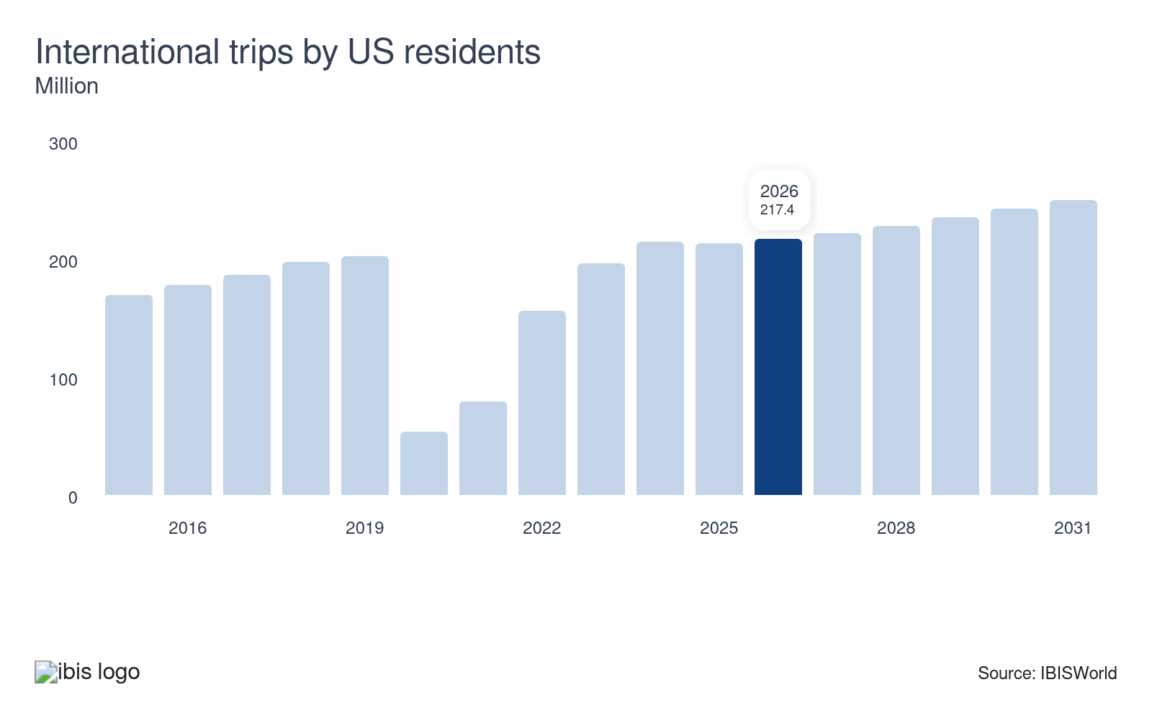
International trips by US residents drive demand for deep-sea cruise offerings. Rising international travel strengthens market positioning for cruise operators specializing in overseas voyages, supporting revenue growth and expanded capacity deployment. Declining international travel reduces demand for these premium, long-distance cruises, constraining revenue streams and limiting growth opportunities for operators dependent on international itineraries.
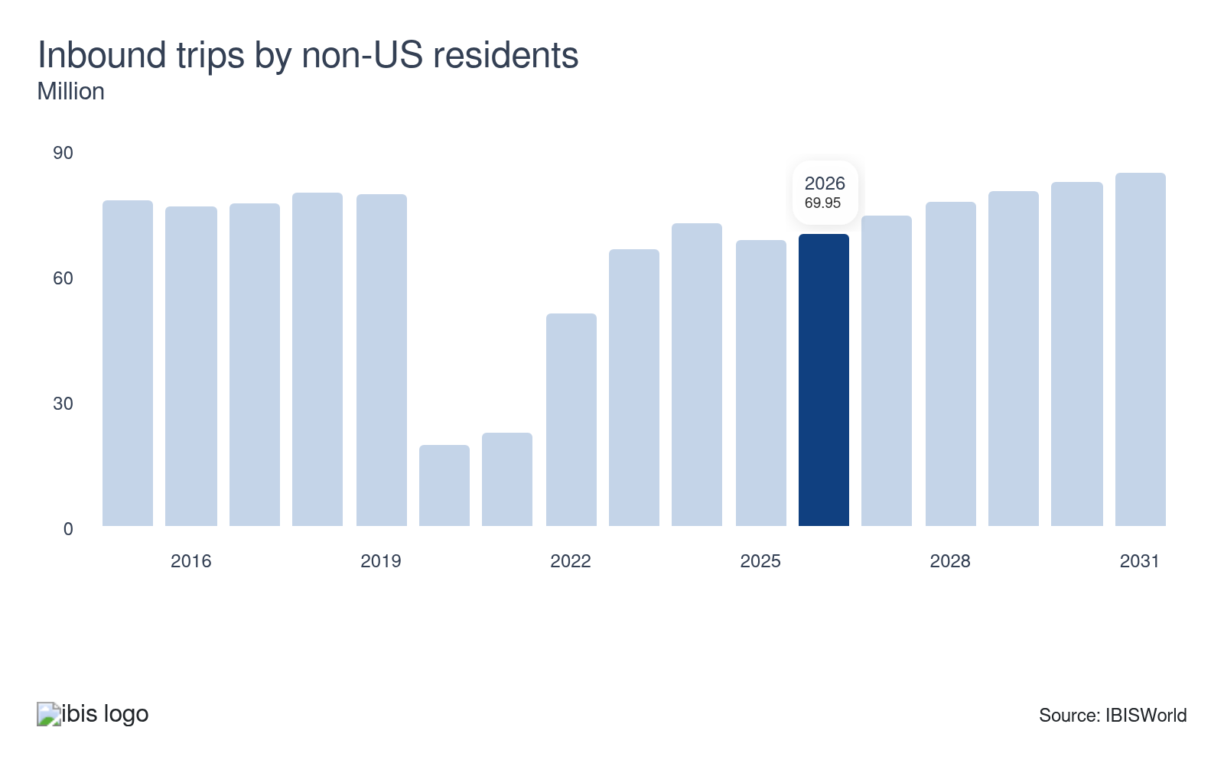
Inbound tourism by international visitors supports cruise operators offering domestic itineraries to major US destinations, such as Alaska. Rising international visitation increases demand for these cruises, strengthening revenue for operators serving overseas travelers, making this an opportunity. Declining international arrivals reduce demand for domestic cruise itineraries, constraining revenue and limiting growth opportunities.
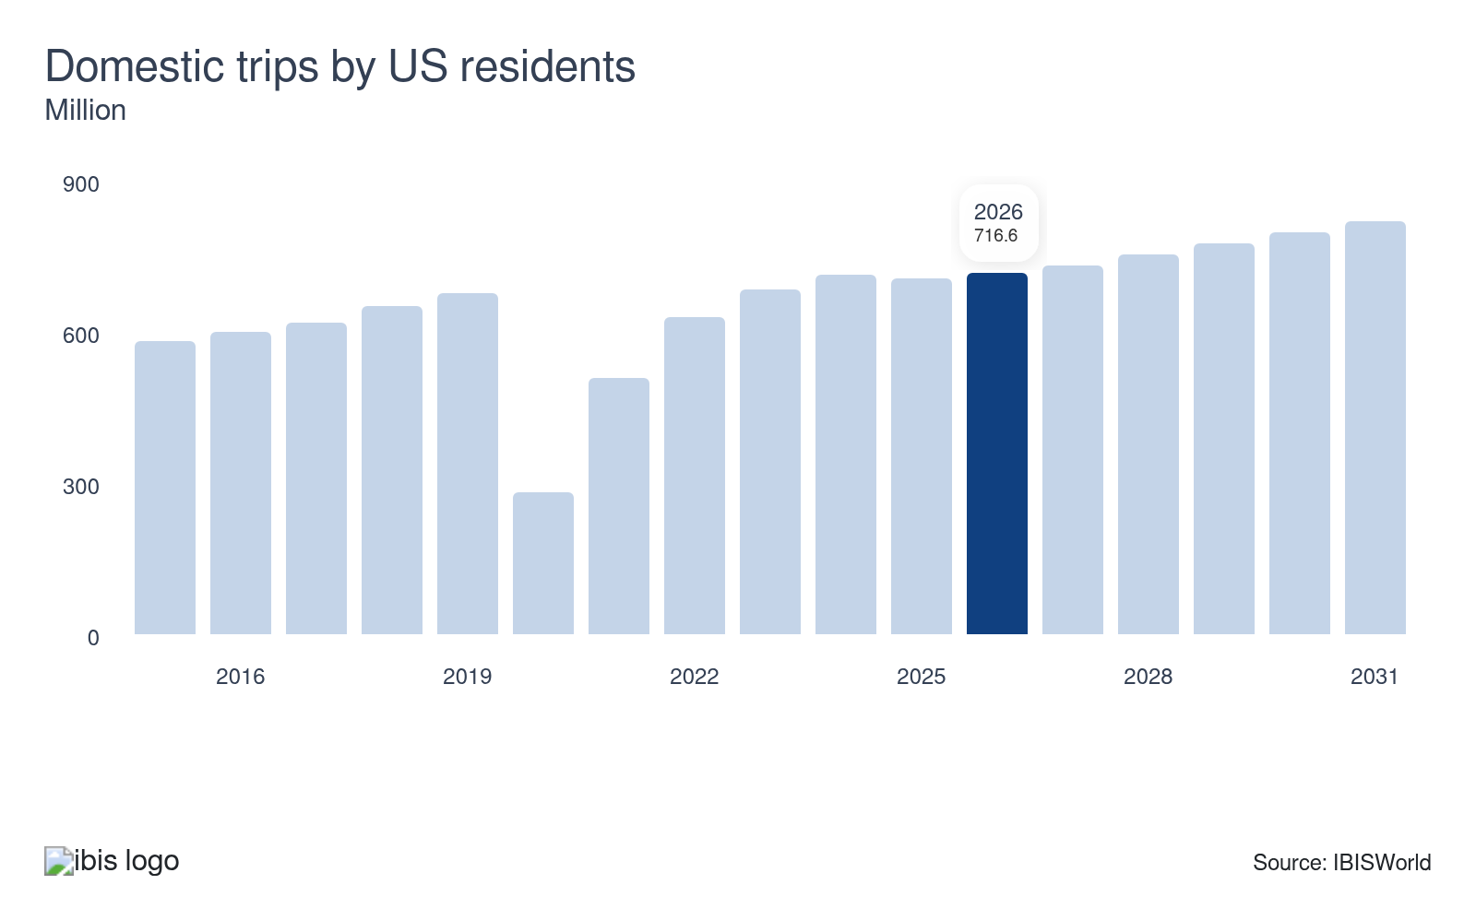
Domestic trips by US residents play a role in the industry. When this rises, factors like increased willingness to take nearby trips, such as in the St. Lawrence or Great Lakes, help bolster interest in cruises that can take anyone wanting to take a trip nearby in the country, which benefits the industry. But when these drop, interest in these ventures declines, which can erode industry demand.

Investors play a critical role in shaping industry infrastructure. Their willingness to fund port construction ventures can secure exclusive berths for vessels in high-demand markets, strengthening operational capacity. When investor uncertainty arises, investment flows slow, constraining infrastructure development and limiting competitive positioning. Infrastructure constraints increase dwell times, delay deliveries and erode client satisfaction, creating operational challenges that ripple through the industry's supply chain and pose a threat.

Regulation & Policy
Moderate | Increasing

What regulations impact the industry?

The Passenger Vessel Services Act of 1886
Operators of international cruise itineraries face a structural compliance constraint under the Passenger Vessel Services Act of 1886, which prohibits foreign-flagged vessels from transporting passengers directly between two US ports, including boarding at one domestic port and disembarking at another. The 1886 Act applies to all cruise lines operating foreign-flagged vessels, which comprises the majority of the US cruise market. In practice, cruise lines route itineraries to include at least one foreign port call to satisfy the law's requirements, adding routing complexity and operational expenses to otherwise domestic schedules. For smaller or regional cruise operators considering coastal itineraries, the Act functions as an entry barrier that advantages US-flagged vessel operators, a market structure consideration that interacts with Jones Act dynamics and the MAP's proposed US-flag incentives.

The Merchant Marine Act of 1920
Domestic route protections under the Merchant Marine Act of 1920 (the Jones Act) require that vessels carrying goods or passengers between US ports be US-built, US-flagged, US-owned and US-crewed. The 1920 Act applies to all coastal and Great Lakes freight movement, meaning that any carrier wishing to participate in domestic trade without a waiver must meet all four ownership and construction requirements, creating a high barrier to foreign-flag competition on domestic routes. A federal energy commodity waiver issued March 18, 2026 and running through August 16, 2026, exposes coastal petroleum operators to direct foreign-flag competition on domestic energy shipping routes for the waiver's full duration. The longer-term trajectory of Jones Act reform remains uncertain, as the current administration's MAP framework simultaneously advocates strengthening US-flag requirements while offering a temporary competitive opening to foreign carriers.

The International Maritime Organization (IMO)
Facing a global sulfur emissions cap of 0.50% mass-by-mass established under the International Maritime Organization's MARPOL Annex VI regulation (effective January 1, 2020), ocean carriers must either burn compliant low-sulfur fuel or fit exhaust gas cleaning systems (scrubbers) across their fleets. Non-compliant vessels face port-state detention, fines and detention by flag-state authorities in any signatory jurisdiction, making non-compliance operationally untenable for carriers serving multiple global ports. Across the fleet, carriers have responded through a combination of scrubber retrofits and a switch to very-low-sulfur fuel oil (VLSFO), with the required capital investment varying significantly by vessel age and class. The compliance choice between scrubbers and VLSFO carries long-term balance sheet implications: scrubber installation involves significant upfront capital. At the same time, VLSFO dependence exposes carriers to ongoing fuel price movements without the hedge that a scrubber-equipped fleet provides against fuel spread volatility.

Assistance
Moderate | Steady

What assistance is available to this industry?

The Merchant Marine Act of 1920
The Jones Act's domestic route monopoly is the foundational public assistance benefiting US ocean and coastal carriers. Codified over a century ago, it requires all goods and passengers transported between US ports to use vessels that are US-built, US-flagged and crewed by US citizens or permanent residents, effectively excluding foreign competition from domestic trade lanes. Despite this structural protection, the legislation is now subject to active policy tension: the White House issued a Jones Act waiver for energy commodities (crude oil, natural gas, fertilizers and coal) running from March 18 to August 16, 2026, opening domestic energy shipping routes to foreign-flagged vessels during the waiver period and creating near-term competitive exposure for coastal petroleum carriers.

The Cruise Lines International Association (CLIA)
The Cruise Lines International Association (CLIA) is the world’s largest cruise industry trade association, representing over 50 ocean, river and specialty cruise lines that together account for the vast majority of global cruise capacity, as well as a broad network of travel agencies, ports and maritime suppliers. CLIA’s core value to members lies in regulatory and policy advocacy: it serves as a non-governmental consultative organization to the International Maritime Organization (IMO). It actively engages with governments and regulators to shape safety, environmental and sustainability rules for the industry.

The United States Travel Association
Travel industry advocacy through the United States Travel Association (USTA) provides indirect support to ocean and coastal carriers whose revenues depend on passenger travel demand. As the national representative for all US travel-related entities, the USTA champions federal policies that facilitate cross-border travel access, visa processing efficiency, and destination marketing — factors that directly affect inbound trips by non-US residents, the single highest-weighted external driver for this industry. Carriers in the deep-sea passenger segment benefit from USTA's advocacy efforts to the extent that those efforts sustain or grow the inbound visitor volumes that fill cruise itineraries.

9. Financial Benchmarks
https://my.ibisworld.com/us/en/industry/48311/financial-benchmarks
Profit Margin  12.7 %  ↑ Higher than sector | Average Wage  $125k  ↑ Higher than sector | Largest Cost  Purchases  20.0% of Revenue

Key Takeaways
- Cruise lines' luxury-focused growth offsets maritime shipping's margin pressure. Strong cruise profitability prevents overall industry profit drop despite freight rate compression in the logistics segment.
- Fuel volatility and hedging choices are reshaping cost pressures. Purchases as a share of revenue ticked back up when oil spiked after the Iran war and outcomes now diverge as hedged players like Royal Caribbean blunt the impact that unhedged rivals fully absorb.

Cost Structure
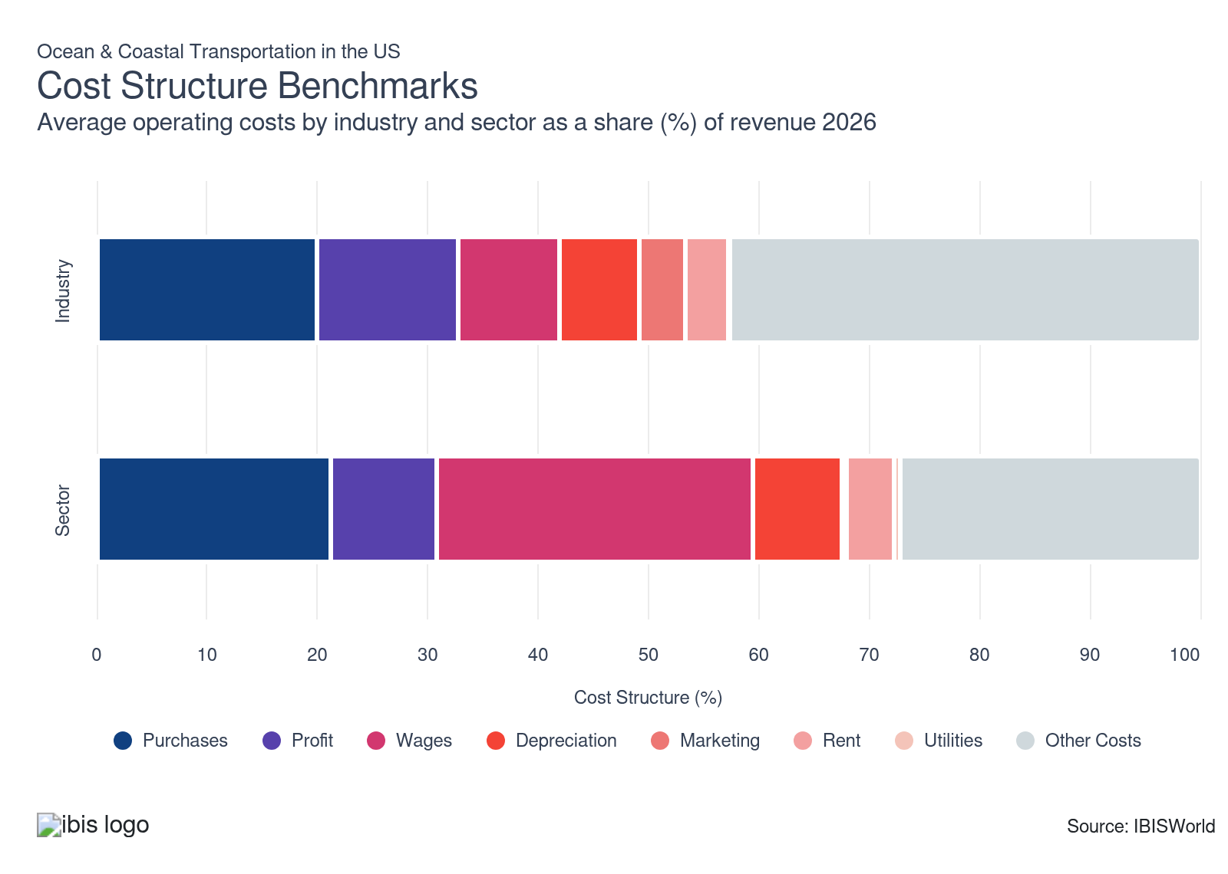
Chart displays current year only in the PDF version of this report. You can view and download chart for all other years associated with this industry on my.ibisworld.com.

What trends impact industry costs?

Cruise market growth masks maritime shipping's profit decline
- Cruise lines expanded into luxury markets and raised prices, driving revenue and profit gains throughout the period. Lower purchasing and wage costs further improved profit. The cruise segment's strong performance increased its share of industry profit, offsetting weakness elsewhere in the sector and supporting overall profitability gains from the period's start.
- Maritime shipping faced margin pressure from declining freight rates that reduced revenue and profit. This weakness persisted into 2023, limiting meaningful industry-wide profit growth despite cruise lines' expansion. The maritime shipping segment's critical role in logistics means its rate compression directly constrains overall industry profit performance, leaving net gains modest despite the cruise sector's strong results.

Rising oil prices push purchase costs back up
- Purchases, which cover fuel, vessel consumables and port supplies, edged down as a share of revenue through 2025 because post-pandemic rate spikes lifted the revenue base faster than input costs. That trend began to reverse in early 2026, when Brent crude rose sharply by mid-March following the Iran war, pushing bunker prices sharply higher and increasing pressure on operators’ purchase profit.
- The cost outlook for purchases now diverges by company strategy, since fuel hedging policies vary across major brands. Royal Caribbean reports that it hedged about 60.0% of expected fuel consumption for the remainder of 2026, which limits the near-term impact of higher bunker prices on its purchase ratio, while peers such as Carnival remain fully exposed to spot fuel markets and face a larger rebound in purchases as a share of revenue.

Scrutiny on wage increases regulates these costs
- Wage costs remain a major expense in the industry, covering pay for ship crews, dockworkers and support staff. Companies rely on skilled workers for safe, efficient operations, but scrutinize wage growth to manage tight budgets.
- Wage costs trended downward over the past five years as companies became more cautious about approving raises amid cost and performance issues. In 2024, the Seafarer Employers’ Association noted pay reviews jumped 10.0%, but nearly 16.0% of companies froze senior officer wages. This imposed moderation on roles that drive up total wage expenditures, slightly slowing the wage share of revenue across the sector.
- This trend matches changes in the broader transportation and warehousing sector, where slower hiring for highly paid pilot positions has similarly capped wage expansion for less experienced workers learning on the job.

Depreciation costs rise as companies rebuild asset bases
- Depreciation in the ocean and coastal transportation industry accounts for a moderate and steady share of operating expenses, as significant investments in ships, containers and port equipment are amortized over decades of service.
- Depreciation expenses have risen as the industry rebounded from pandemic-related shutdowns at the start of the period. As operations resumed, companies expanded their asset bases, generating higher depreciation costs. This trend mirrors the broader transportation and warehousing sector, where depreciation expenses also climbed during the period. The climb reflects ongoing capital investment and the strategic use of bonus depreciation, which allows companies to accelerate deductions on newly acquired assets.

Cruise organizations boost marketing spend to capture growing travel demand
- Marketing costs make up a small share of total industry costs, because most business comes from repeat B2B contracts instead of consumer channels. Sponsorships, digital tools and face-to-face engagement still matter, but they’re overshadowed in budgets by far higher operational costs.
- These segments expanded during the period as major cruise operators increased marketing spending to capture travel demand and maintain competitiveness. Carnival, for example, increased advertising spend by 30.0% from Q1 2019 to Q1 2023, targeting new-to-cruising customers. The company's "Choose Fun Together" campaign focused on family and group travel, reflecting intensified promotional efforts across the cruise industry as travel demand rebounded.

Port terminal lease commitments are lifting rent costs as cruise lines lock in homeport access
- Driven by record passenger volumes and the operational necessity of guaranteed berthing in high-demand homeports, cruise operators have signed major long-term terminal agreements, nudging the rent share of revenue upward. Rent covers vessel charters, port terminal leases and large-scale storage facilities, costs that scale directly with passenger throughput and vessel dimensions.
- Norwegian Cruise Line's commitment to a facility at Galveston Wharves and Carnival Corporation's decade-long lease in Seattle together illustrate how competitive pressure for prime berthing space is translating into longer, higher-cost agreements, as per the prior period's deal disclosures. Unlike land-based logistics operators, which have reduced rent exposure through improved space utilization and consolidation, cruise lines cannot substitute smaller or shared terminals, as vessel dimensions and turnaround requirements mandate dedicated, high-capacity facilities that command a premium in major homeports.

Utility costs remain negligible, anchored by slow but steady shore power adoption
- At just 0.2% of revenue and flat year over year, utility costs are the smallest cost item in the industry. The stabilizing force is partial adoption of shore power, which draws electricity from the local grid to replace onboard fuel generation. At the same time, vessels are docked, which helps hold down energy consumption during the port stays, which account for most stationary utility demand.
- Despite sector-level gains from energy-efficient vehicle fleets and smart facility management that have driven utility costs lower across transportation and warehousing, adoption in ocean shipping remains uneven. Legacy vessels continue to operate on generators during port calls, keeping average utility spending from declining even as newer ships switch to cleaner, cheaper shore connections. Until fleet renewal accelerates, the uneven technology mix will keep this cost line stable.
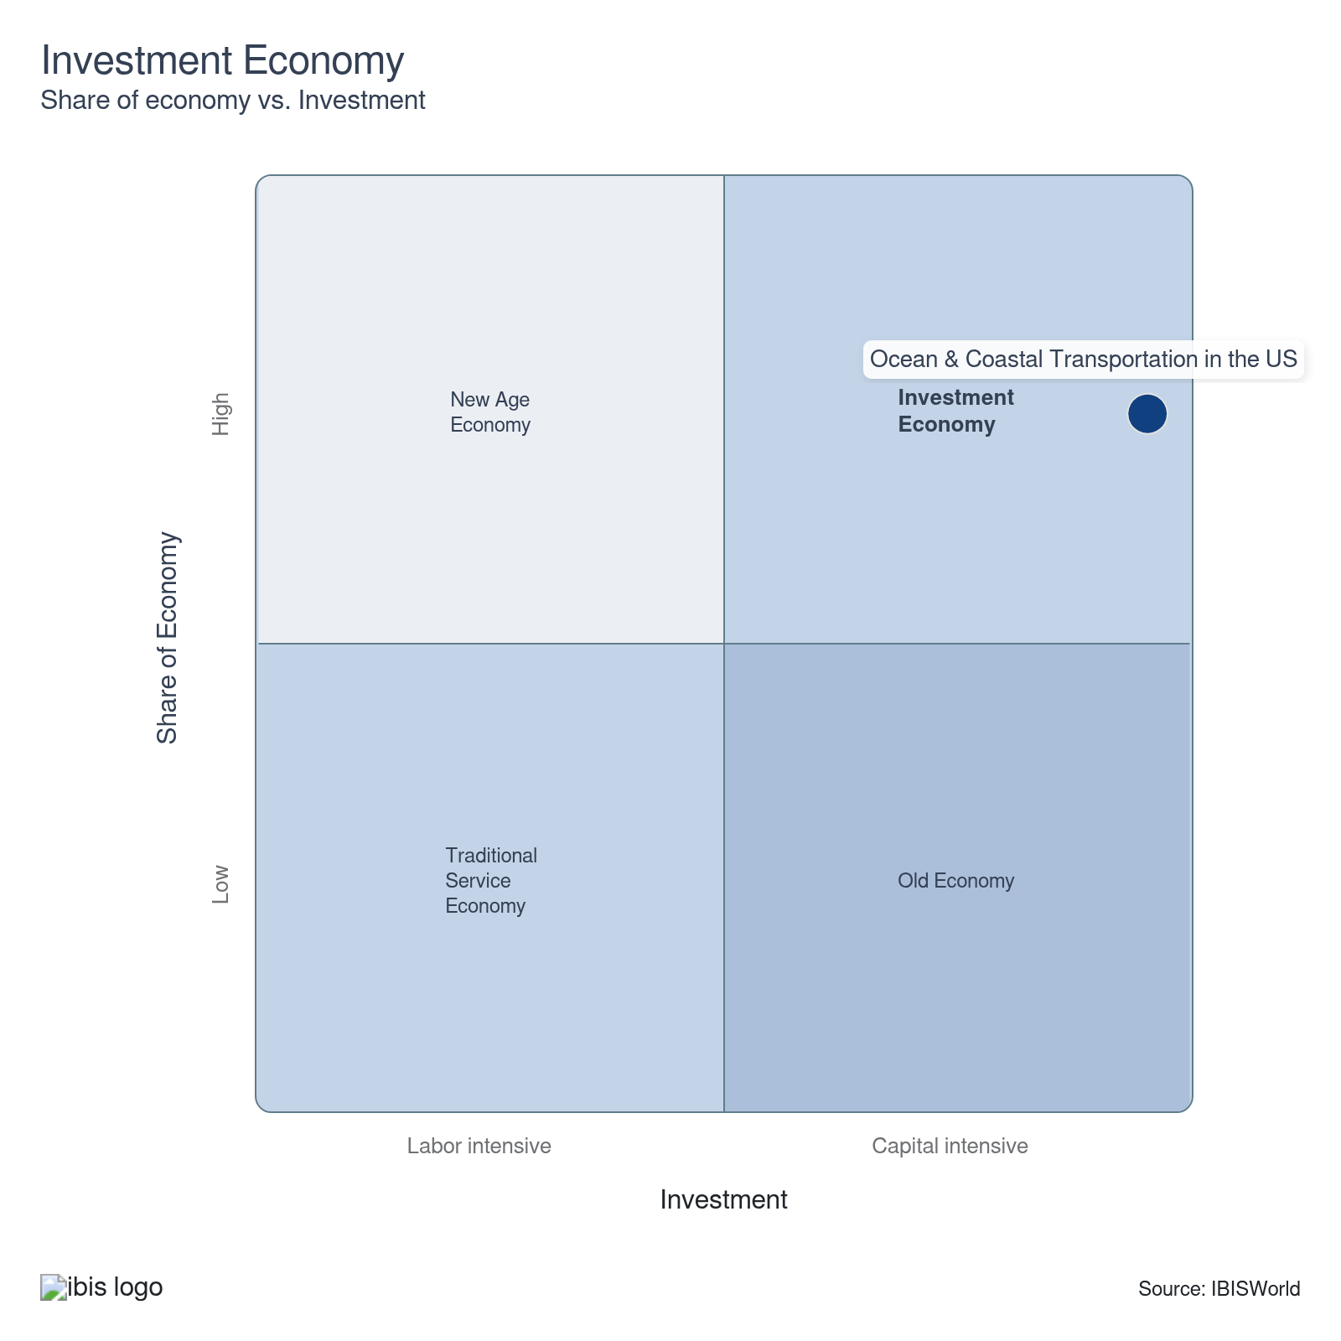

Financial Ratios

Earnings Ratios
Ratio | 2020 | 2021 | 2022 | 2023 | 2024 | 3-Year | 5-Year | 10-Year
EBIT/Revenue | 15.9 | 14.9 | 18.4 | 19.0 | 13.2 | 16.1 | 16.4 | 14.5
EBITDA/Revenue | 26.3 | 25.8 | 26.0 | 28.6 | 20.2 | 24.4 | 25.2 | 24.3
Leverage Ratio | 1.9 | 3.9 | 2.9 | 2.5 | 3.4 | 2.9 | 3.2 | 2.9

Industry Tax Structure
Ratio | 2020 | 2021 | 2022 | 2023 | 2024 | 3-Year | 5-Year | 10-Year
Taxes Paid/Revenue | 4.0 | 3.8 | 2.3 | 2.8 | 3.1 | 2.9 | 3.0 | 3.7

Income Statement
Ratio | 2020 | 2021 | 2022 | 2023 | 2024 | 3-Year | 5-Year | 10-Year
Total Revenue | 100.0 | 100.0 | 100.0 | 100.0 | 100.0 | 100.0 | 100.0 | 100.0
Business receipts | 84.5 | 85.0 | 90.1 | 90.4 | 93.5 | 91.9 | 89.7 | 90.3
Cost of goods | 32.3 | 35.2 | 37.3 | 25.0 | 24.7 | 24.9 | 30.6 | 33.0
Gross Profit | 67.7 | 64.8 | 62.7 | 75.0 | 75.3 | 75.1 | 69.4 | 67.0
Expenses
Salaries and wages | 9.0 | 6.5 | 5.4 | 7.7 | 7.8 | 7.7 | 6.9 | 8.2
Advertising | 1.8 | 0.9 | 0.9 | 1.9 | 2.0 | 1.9 | 1.4 | 2.0
Depreciation | 6.8 | 7.4 | 5.4 | 3.6 | 4.0 | 3.8 | 5.1 | 6.3
Depletion | 3.0 | 3.4 | 1.7 | 0.2 | 0.1 | 0.2 | 1.4 | 1.7
Amortization | 0.7 | 0.1 | 0.5 | 5.8 | 3.0 | 4.4 | 2.4 | 1.8
Rent paid | 1.8 | 1.1 | 1.1 | 2.1 | 2.0 | 2.0 | 1.6 | 1.9
Repairs | 0.9 | 1.4 | 0.8 | 0.4 | 0.2 | 0.3 | 0.7 | 0.7
Bad debts | 0.1 | 1.6 | 0.6 | 0.7 | 0.6 | 0.7 | 0.9 | 1.1
Employee benefit programs | 3.5 | 3.1 | 2.2 | 3.1 | 3.7 | 3.4 | 3.0 | 3.5
Compensation of officers | 2.4 | 2.8 | 1.3 | 7.3 | 10.4 | 8.8 | 5.5 | 3.2
Taxes paid | 4.0 | 3.8 | 2.3 | 2.8 | 3.1 | 2.9 | 3.0 | 3.7
Interest Income | 0.9 | 0.6 | 1.0 | 0.5 | 0.3 | 0.4 | 0.6 | 1.0
Other Income
Royalties | 3.4 | 4.0 | 1.3 | 2.6 | 1.3 | 2.0 | 2.3 | 1.5
Rent Income | 6.9 | 5.6 | 4.0 | 0.8 | 0.4 | 0.6 | 2.7 | 3.6
Net Income | 6.8 | 6.3 | 11.8 | 4.6 | 3.9 | 4.2 | 6.6 | 3.9
Charitable contributions | 0.0 | 0.1 | 0.1 | 0.2 | 0.1 | 0.1 | 0.1 | 0.1
Dividends | 0.0 | 0.0 | 0.0 | 1.2 | 1.7 | 1.4 | 0.7 | 0.3
Interest paid | 5.0 | 4.8 | 4.4 | 11.6 | 6.1 | 8.9 | 6.7 | 6.9
Net gain, noncapital assets | 2.3 | 1.9 | 1.4 | 0.7 | 0.4 | 0.5 | 1.1 | 1.3
Net long-term capital gain less net short-term loss | 0.5 | 0.9 | 0.6 | 0.2 | 0.1 | 0.2 | 0.5 | 0.4
Net loss, noncapital assets | 3.3 | 3.7 | 2.0 | 0.8 | 0.4 | 0.6 | 1.8 | 2.1
Net short-term capital gain less net long-term loss | 0.5 | 0.9 | 0.6 | 2.6 | 1.3 | 1.9 | 1.3 | 0.7
Other deductions | 16.8 | 15.9 | 21.2 | 20.3 | 25.4 | 22.8 | 20.7 | 18.4
Other receipts | 0.9 | 1.1 | 1.0 | 1.0 | 1.0 | 1.0 | 1.0 | 0.9
Pension, profit-sharing, etc., plans | 1.7 | 1.8 | 1.0 | 1.9 | 2.4 | 2.2 | 1.8 | 1.6

Balance Sheet
Ratio | 2020 | 2021 | 2022 | 2023 | 2024 | 3-Year | 5-Year | 10-Year
Assets
Cash and Equivalents | 7.9 | 5.7 | 15.2 | 4.7 | 3.3 | 4.0 | 7.2 | 6.0
Notes and accounts receivable | 9.2 | 7.8 | 2.8 | 8.3 | 5.3 | 6.8 | 6.0 | 6.0
Allowance for bad debts | 0.1 | 0.3 | 0.2 | 0.5 | 0.6 | 0.6 | 0.4 | 0.3
Inventories | 1.2 | 1.2 | 3.3 | 7.9 | 10.5 | 9.2 | 5.8 | 3.2
Other current assets | 1.2 | 2.7 | 0.6 | 3.0 | 2.6 | 2.8 | 2.2 | 3.0
Other investments | 29.9 | 35.4 | 16.7 | 25.7 | 26.1 | 25.9 | 26.0 | 31.1
Property, Plant and Equipment | 39.1 | 32.4 | 45.2 | 43.2 | 36.8 | 40.0 | 39.4 | 43.3
Accumulated depreciation | 13.5 | 10.7 | 13.9 | 27.8 | 22.4 | 25.1 | 18.7 | 19.6
Intangible assets (Amortizable) | 6.1 | 7.8 | 0.5 | 11.3 | 15.1 | 13.2 | 8.7 | 7.4
Accumulated amortization | 0.6 | 3.2 | 0.1 | 1.5 | 1.9 | 1.7 | 1.7 | 1.2
Other assets | 5.7 | 6.7 | 13.6 | 6.8 | 7.5 | 7.2 | 8.6 | 7.0
Total assets | 100.0 | 100.0 | 100.0 | 100.0 | 100.0 | 100.0 | 100.0 | 100.0
Accounts payable | 0.9 | 4.4 | 5.6 | 5.5 | 3.7 | 4.6 | 4.8 | 5.3
Liabilities and Net Worth
Mort, notes, and bonds under 1 yr | 8.6 | 9.7 | 7.9 | 9.5 | 10.1 | 9.8 | 9.3 | 8.9
Other current liabilities | 5.0 | 4.8 | 4.4 | 3.9 | 2.5 | 3.2 | 3.9 | 4.4
Loans from shareholders | 2.7 | 2.8 | 1.1 | 3.7 | 4.0 | 3.9 | 2.9 | 2.0
Mort, notes, bonds, 1 yr or more | 42.7 | 45.7 | 42.7 | 42.1 | 45.3 | 43.7 | 44.0 | 39.9
Other liabilities | 4.2 | 5.4 | 9.2 | 9.2 | 9.6 | 9.4 | 8.3 | 9.7
Total liabilities | 100.0 | 100.0 | 100.0 | 100.0 | 100.0 | 100.0 | 100.0 | 100.0
Capital stock | 14.9 | 12.2 | 5.3 | 1.4 | -0.9 | 0.3 | 4.5 | 5.6
Additional paid-in capital | 28.9 | 27.2 | 31.9 | 22.1 | 22.5 | 22.3 | 25.9 | 27.1
Retained earnings, appropriated | -3.4 | 0.1 | -5.9 | -4.4 | -3.3 | -3.8 | -3.4 | -2.9
Retained earnings-unappropriated | 11.6 | 3.0 | 16.0 | 23.5 | 24.1 | 23.8 | 16.6 | 13.9
Cost of treasury stock | 16.1 | 15.4 | 18.1 | 16.5 | 17.6 | 17.1 | 16.9 | 13.9
Net worth | 35.9 | 27.1 | 29.1 | 26.1 | 24.7 | 25.4 | 26.8 | 29.8
Accumulated depletion | 0.0 | 0.0 | 0.0 | 0.5 | 0.1 | 0.3 | 0.1 | 0.2
Depletable assets | 2.3 | 2.3 | 2.3 | 1.8 | 0.5 | 1.2 | 1.8 | 2.3
Government Obligations | 0.0 | 0.0 | 0.0 | 0.0 | 0.0 | 0.0 | 0.0 | 0.0
Land | 9.3 | 9.3 | 9.4 | 5.7 | 4.9 | 5.3 | 7.3 | 7.1
Loans to shareholders | 0.3 | 0.7 | 2.0 | 1.6 | 1.4 | 1.5 | 1.4 | 0.9
Mortgage and real estate loans | 1.8 | 2.0 | 2.6 | 9.6 | 10.6 | 10.1 | 6.2 | 3.9
Tax Exempt Securities | 0.1 | 0.0 | 0.0 | 0.5 | 0.3 | 0.4 | 0.2 | 0.2

Liquidity Ratios
Ratio | 2020 | 2021 | 2022 | 2023 | 2024 | 3-Year | 5-Year | 10-Year
Current Ratio | 1.4 | 0.9 | 1.2 | 1.3 | 1.4 | 1.4 | 1.2 | 1.0
Quick Ratio | 1.3 | 0.9 | 1.1 | 0.9 | 0.7 | 0.8 | 0.9 | 0.8
Sales/Receivables | 10.9 | 12.9 | 36.3 | 12.0 | 19.0 | 15.5 | 20.0 | 20.6
Days' Receivables | 33.5 | 28.3 | 10.1 | 30.3 | 19.2 | 24.8 | 22.0 | 22.0
Days' Inventory | 7.0 | 12.9 | 24.6 | 82.0 | 105.5 | 93.7 | 56.2 | 28.8
Inventory Turnover | 52.2 | 28.3 | 14.8 | 4.5 | 3.5 | 4.0 | 12.8 | 36.1
Payables Turnover | 73.2 | 8.0 | 8.8 | 6.5 | 9.8 | 8.1 | 8.3 | 16.1
Days' Payables | 5.0 | 45.8 | 41.3 | 56.4 | 37.2 | 46.8 | 45.2 | 39.7
Sales/Working Capital | 7.6 | -72.0 | 11.7 | 10.9 | 12.9 | 11.9 | -9.2 | -12.6

Coverage Ratios
Ratio | 2020 | 2021 | 2022 | 2023 | 2024 | 3-Year | 5-Year | 10-Year
Interest Coverage | 3.1 | 3.1 | 4.2 | 1.6 | 2.1 | 1.9 | 2.8 | 2.4
Debt Service Coverage Ratio | 1.8 | 1.1 | 1.1 | 1.7 | 1.0 | 1.4 | 1.2 | 1.6

Leverage Ratios
Ratio | 2020 | 2021 | 2022 | 2023 | 2024 | 3-Year | 5-Year | 10-Year
Fixed Assets/Net Worth | 2.0 | 2.4 | 2.5 | 3.5 | 3.3 | 3.4 | 2.9 | 2.8
Debt/Net Worth | 2.8 | 3.7 | 3.4 | 3.8 | 4.0 | 3.9 | 3.7 | 3.4
Tangible Net Worth | 35.9 | 27.1 | 29.1 | 26.1 | 24.7 | 25.4 | 26.8 | 29.8

Operating Ratios
Ratio | 2020 | 2021 | 2022 | 2023 | 2024 | 3-Year | 5-Year | 10-Year
Return on Net Worth, % | 87.5 | 54.9 | 83.4 | 102.3 | 78.4 | 90.3 | 79.7 | 74.3
Return on Assets, % | 15.9 | 14.9 | 18.4 | 19.0 | 13.2 | 16.1 | 16.4 | 14.5
Sales/Total Assets | 1.0 | 1.0 | 1.0 | 1.0 | 1.0 | 1.0 | 1.0 | 1.0
EBITDA/Revenue | 26.3 | 25.8 | 26.0 | 28.6 | 20.2 | 24.4 | 25.2 | 24.3
EBIT/Revenue | 15.9 | 14.9 | 18.4 | 19.0 | 13.2 | 16.1 | 16.4 | 14.5

Cash Flow & Debt Service Ratios (% of sales)
Ratio | 2020 | 2021 | 2022 | 2023 | 2024 | 3-Year | 5-Year | 10-Year
Cash from Trading | 78.2 | 57.0 | 57.5 | 77.2 | 72.0 | 74.6 | 65.9 | 65.5
Cash after Operations | 64.8 | 43.9 | 49.7 | 56.1 | 49.0 | 52.5 | 49.7 | 49.5
Net Cash after Operations | 65.7 | 42.7 | 50.3 | 64.5 | 52.5 | 58.5 | 52.5 | 51.7
Debt Service P&I Coverage | 5.9 | 2.7 | 4.4 | 3.2 | 3.5 | 3.3 | 3.5 | 3.6
Interest Coverage (Operating Cash) | 13.0 | 8.8 | 11.5 | 5.5 | 8.6 | 7.1 | 8.6 | 8.2

Valuation Multiples

Valuation Multiples
Ratio | 2020 | 2021 | 2022 | 2023 | 2024 | 3-Year | 5-Year | 10-Year
EV/Revenue | 0.8 | 0.8 | 0.7 | 0.8 | 0.8 | 0.7 | 0.7 | 0.7
EV/EBITDA | 1.3 | 1.3 | 1.3 | 1.3 | 1.6 | 1.4 | 1.3 | 1.5
EV/EBIT | 2.1 | 2.3 | 1.8 | 2.0 | 2.4 | 2.1 | 2.1 | 2.5

Key Ratios
Year | Revenue per Employee  ($) | Revenue per Enterprise  ($ Million) | Employees per Estab.  (Units) | Employees per Enterprise  (Units) | Average Wage  ($) | Wages/ Revenue  (%) | Estab. per Enterprise  (Units) | IVA/ Revenue  (%)
2007 | 893,144 | 48.4 | 38.4 | 54.1 | 102,919 | 11.5 | 1.4 | 42.0
2008 | 881,742 | 53.6 | 43.9 | 60.8 | 106,376 | 12.1 | 1.4 | 37.0
2009 | 830,742 | 48.5 | 42.1 | 58.4 | 98,399 | 11.8 | 1.4 | 32.5
2010 | 998,818 | 54.3 | 38.0 | 54.3 | 101,425 | 10.2 | 1.4 | 30.1
2011 | 978,024 | 55.2 | 39.5 | 56.5 | 103,560 | 10.6 | 1.4 | 24.5
2012 | 941,779 | 61.2 | 45.5 | 65.0 | 101,465 | 10.8 | 1.4 | 26.4
2013 | 1,036,429 | 69.6 | 46.5 | 67.1 | 99,146 | 9.6 | 1.4 | 28.5
2014 | 1,037,749 | 64.1 | 41.9 | 61.8 | 106,664 | 10.3 | 1.5 | 25.4
2015 | 1,059,030 | 60.9 | 39.7 | 57.5 | 112,081 | 10.6 | 1.4 | 24.7
2016 | 1,111,049 | 62.9 | 37.7 | 56.6 | 112,008 | 10.1 | 1.5 | 40.7
2017 | 1,151,532 | 65.1 | 38.5 | 56.5 | 115,669 | 10.0 | 1.5 | 32.5
2018 | 1,190,003 | 69.3 | 40.2 | 58.2 | 114,370 | 9.6 | 1.4 | 37.5
2019 | 1,242,316 | 69.6 | 39.9 | 56.0 | 116,833 | 9.4 | 1.4 | 38.0
2020 | 651,497 | 37.8 | 41.2 | 58.0 | 105,383 | 16.2 | 1.4 | 47.1
2021 | 660,134 | 30.8 | 33.9 | 46.7 | 118,119 | 17.9 | 1.4 | 35.8
2022 | 1,130,171 | 56.1 | 37.6 | 49.6 | 117,573 | 10.4 | 1.3 | 25.9
2023 | 1,317,888 | 65.9 | 38.0 | 50.0 | 124,153 | 9.4 | 1.3 | 29.5
2024 | 1,347,874 | 69.0 | 38.8 | 51.2 | 124,723 | 9.3 | 1.3 | 29.5
2025 | 1,352,996 | 69.5 | 39.0 | 51.4 | 124,817 | 9.2 | 1.3 | 29.4
2026 | 1,354,903 | 69.6 | 39.0 | 51.4 | 124,848 | 9.2 | 1.3 | 29.2
2027 | 1,365,204 | 70.5 | 39.2 | 51.7 | 125,039 | 9.2 | 1.3 | 28.9
2028 | 1,376,070 | 71.5 | 39.4 | 52.0 | 125,236 | 9.1 | 1.3 | 28.5
2029 | 1,378,013 | 72.3 | 39.8 | 52.5 | 125,272 | 9.1 | 1.3 | 28.8
2030 | 1,380,174 | 72.7 | 40.0 | 52.7 | 125,313 | 9.1 | 1.3 | 29.2
2031 | 1,381,278 | 73.1 | 40.1 | 52.9 | 125,332 | 9.1 | 1.3 | 29.1
2032 | 1,383,068 | 73.4 | 40.3 | 53.1 | 125,365 | 9.1 | 1.3 | 29.1
*Figures are inflation adjusted to 2026
*Figures are inflation adjusted to 2026

10. Key Statistics
https://my.ibisworld.com/us/en/industry/48311/key-statistics

Industry Data

Values
Year | Revenue  ($ Million) | IVA  ($ Million) | Estab.  (Units) | Enterprises  (Units) | Employment  (Units) | Wages  ($ Million)
2007 | 43,031.7 | 18,089.2 | 1,255 | 890 | 48,180 | 4,958.6
2008 | 43,558.0 | 16,134.0 | 1,126 | 813 | 49,400 | 5,255.0
2009 | 40,223.7 | 13,073.9 | 1,150 | 829 | 48,419 | 4,764.4
2010 | 43,959.0 | 13,233.6 | 1,157 | 810 | 44,011 | 4,463.8
2011 | 44,955.8 | 10,996.4 | 1,163 | 814 | 45,966 | 4,760.3
2012 | 46,632.2 | 12,316.2 | 1,089 | 762 | 49,515 | 5,024.1
2013 | 47,666.4 | 13,566.6 | 988 | 685 | 45,991 | 4,559.8
2014 | 48,685.0 | 12,364.8 | 1,119 | 759 | 46,914 | 5,004.1
2015 | 47,955.0 | 11,868.1 | 1,141 | 787 | 45,282 | 5,075.3
2016 | 47,494.0 | 19,329.8 | 1,134 | 755 | 42,747 | 4,788.0
2017 | 47,731.0 | 15,514.9 | 1,076 | 733 | 41,450 | 4,794.5
2018 | 50,095.6 | 18,766.7 | 1,048 | 723 | 42,097 | 4,814.6
2019 | 52,210.8 | 19,819.9 | 1,054 | 750 | 42,027 | 4,910.1
2020 | 29,083.5 | 13,690.0 | 1,084 | 770 | 44,641 | 4,704.4
2021 | 24,881.1 | 8,901.8 | 1,112 | 807 | 37,691 | 4,452.0
2022 | 46,539.3 | 12,042.0 | 1,095 | 830 | 41,179 | 4,841.5
2023 | 54,916.4 | 16,183.6 | 1,098 | 833 | 41,670 | 5,173.5
2024 | 58,891.3 | 17,396.1 | 1,127 | 854 | 43,692 | 5,449.4
2025 | 60,140.7 | 17,681.8 | 1,141 | 865 | 44,450 | 5,548.1
2026 | 61,098.0 | 17,832.2 | 1,157 | 878 | 45,094 | 5,629.9
2027 | 63,398.7 | 18,349.4 | 1,184 | 899 | 46,439 | 5,806.7
2028 | 65,657.8 | 18,734.1 | 1,210 | 918 | 47,714 | 5,975.5
2029 | 67,674.2 | 19,499.9 | 1,233 | 936 | 49,110 | 6,152.1
2030 | 69,530.4 | 20,290.7 | 1,260 | 956 | 50,378 | 6,313.0
2031 | 71,419.0 | 20,799.8 | 1,288 | 977 | 51,705 | 6,480.3
2032 | 73,320.6 | 21,305.1 | 1,317 | 999 | 53,013 | 6,646.0

*Figures are inflation adjusted to 2026

Annual Change
Year | Revenue  % | IVA  % | Estab.  % | Enterprises  % | Employment  % | Wages  %
2007 | N/A | N/A | N/A | N/A | N/A | N/A
2008 | 1.2 | -10.8 | -10.3 | -8.7 | 2.5 | 6.0
2009 | -7.7 | -19.0 | 2.1 | 2.0 | -2.0 | -9.3
2010 | 9.3 | 1.2 | 0.6 | -2.3 | -9.1 | -6.3
2011 | 2.3 | -16.9 | 0.5 | 0.5 | 4.4 | 6.6
2012 | 3.7 | 12.0 | -6.4 | -6.4 | 7.7 | 5.5
2013 | 2.2 | 10.2 | -9.3 | -10.1 | -7.1 | -9.2
2014 | 2.1 | -8.9 | 13.3 | 10.8 | 2.0 | 9.7
2015 | -1.5 | -4.0 | 2.0 | 3.7 | -3.5 | 1.4
2016 | -1.0 | 62.9 | -0.6 | -4.1 | -5.6 | -5.7
2017 | 0.5 | -19.7 | -5.1 | -2.9 | -3.0 | 0.1
2018 | 5.0 | 21.0 | -2.6 | -1.4 | 1.6 | 0.4
2019 | 4.2 | 5.6 | 0.6 | 3.7 | -0.2 | 2.0
2020 | -44.3 | -30.9 | 2.8 | 2.7 | 6.2 | -4.2
2021 | -14.4 | -35.0 | 2.6 | 4.8 | -15.6 | -5.4
2022 | 87.0 | 35.3 | -1.5 | 2.9 | 9.3 | 8.7
2023 | 18.0 | 34.4 | 0.3 | 0.4 | 1.2 | 6.9
2024 | 7.2 | 7.5 | 2.6 | 2.5 | 4.9 | 5.3
2025 | 2.1 | 1.6 | 1.2 | 1.3 | 1.7 | 1.8
2026 | 1.6 | 0.9 | 1.4 | 1.5 | 1.4 | 1.5
2027 | 3.8 | 2.9 | 2.3 | 2.4 | 3.0 | 3.1
2028 | 3.6 | 2.1 | 2.2 | 2.1 | 2.7 | 2.9
2029 | 3.1 | 4.1 | 1.9 | 2.0 | 2.9 | 3.0
2030 | 2.7 | 4.1 | 2.2 | 2.1 | 2.6 | 2.6
2031 | 2.7 | 2.5 | 2.2 | 2.2 | 2.6 | 2.7
2032 | 2.7 | 2.4 | 2.3 | 2.3 | 2.5 | 2.6

*Figures are inflation adjusted to 2026

DISCLAIMER
This product has been supplied by IBISWorld Inc. (‘IBISWorld’) solely for use by its authorized licenses strictly in accordance with their license agreements with IBISWorld. IBISWorld makes no representation to any other person with regard to the completeness or accuracy of the data or information contained herein, and it accepts no responsibility and disclaims all liability (save for liability which cannot be lawfully disclaimed) for loss or damage whatsoever suffered or incurred by any other person resulting from the use of, or reliance upon, the data or information contained herein. Copyright in this publication is owned by IBISWorld Inc. The publication is sold on the basis that the purchaser agrees not to copy the material contained within it for other than the purchasers own purposes. In the event that the purchaser uses or quotes from the material in this publication – in papers, reports, or opinions prepared for any other person – it is agreed that it will be sourced to: IBISWorld Inc.

